Making up 42% of the state's generated electricity in 2019, wind power is the largest source of electricity generation in Iowa. In 2019, over 26 billion kWh of electrical energy was generated by wind power. As of Q1 2020, Iowa has over 10,664 megawatts (MW) of installed capacity with 5,590 wind turbines, ranking 2nd and 3rd in the nation below Texas.

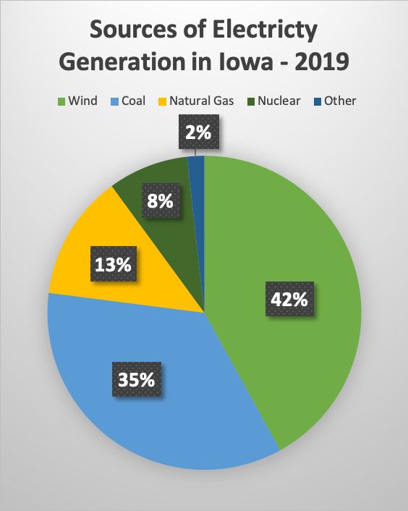

Wind farms are most prevalent in the north and west portion of Iowa. Wind maps show the winds in these areas to be stronger on average, making them better suited for the development of wind energy. Average wind speeds are not consistent from month to month. Wind maps show wind speeds are on average strongest from November through April, peaking in March. August is the month with the weakest average wind speeds.
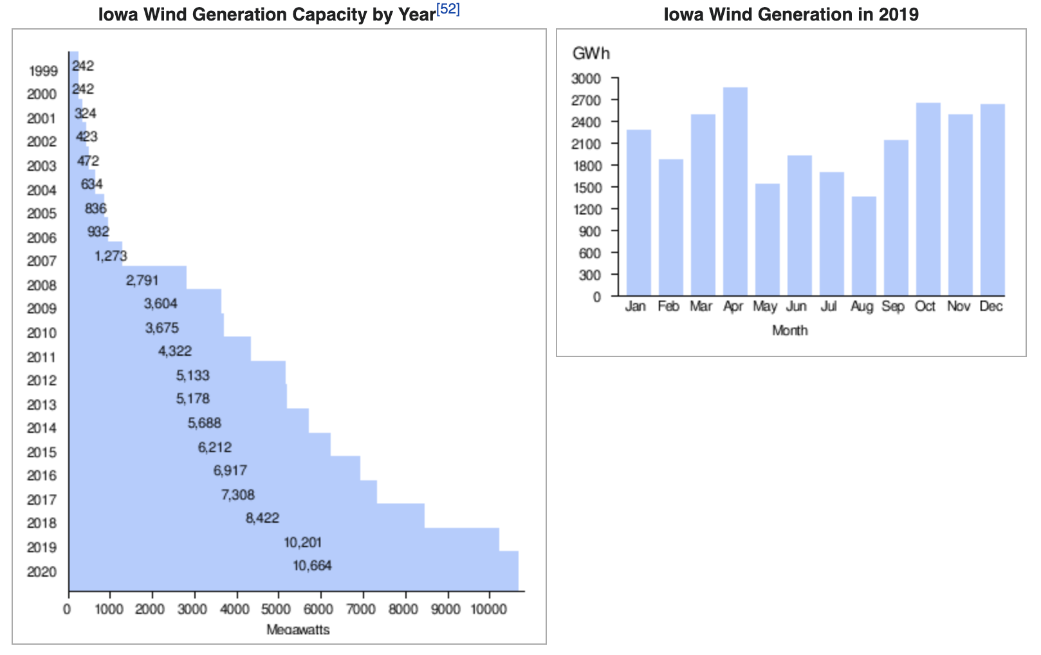

Reference:
1. Webber, Tim (April 16, 2020). "Wind blows by coal to become Iowa's largest source of electricity". Des Moines Register. Retrieved 2020-05-02.
https://www.desmoinesregister.com/story/tech/science/environment/2020/04/16/wind-energy-iowa-largest-source-electricity/5146483002/
2. "US wind energy generation reached 5.5% of the grid in 2016". REVE - Wind Energy and Electric Vehicle Review. 6 March 2017.
http://www.evwind.es/2017/03/06/us-wind-energy-generation-reached-5-5-of-the-grid-in-2016/59000
3. "Wind Energy in Iowa" (PDF). American Wind Energy Association. Retrieved June 2, 2020.
https://www.awea.org/Awea/media/Resources/StateFactSheets/Iowa.pdf

4. https://www.iowaeconomicdevelopment.com/energy

MidAmerican Energy Company is an energy company based in Des Moines, Iowa. Its service area includes almost two-thirds of Iowa, as well as portions of Illinois, South Dakota, and Nebraska. Its territory is wholly encompassed by the territory of the Midcontinent Independent System Operator. Major cities in MidAmerican Energy's service territory are Des Moines, Sioux City, Sioux Falls, Council Bluffs, Waterloo, Iowa City, and the Quad Cities. In 2019, MidAmerican paid approximately $30.9 million in landowner easement/lease payments for our wind projects.
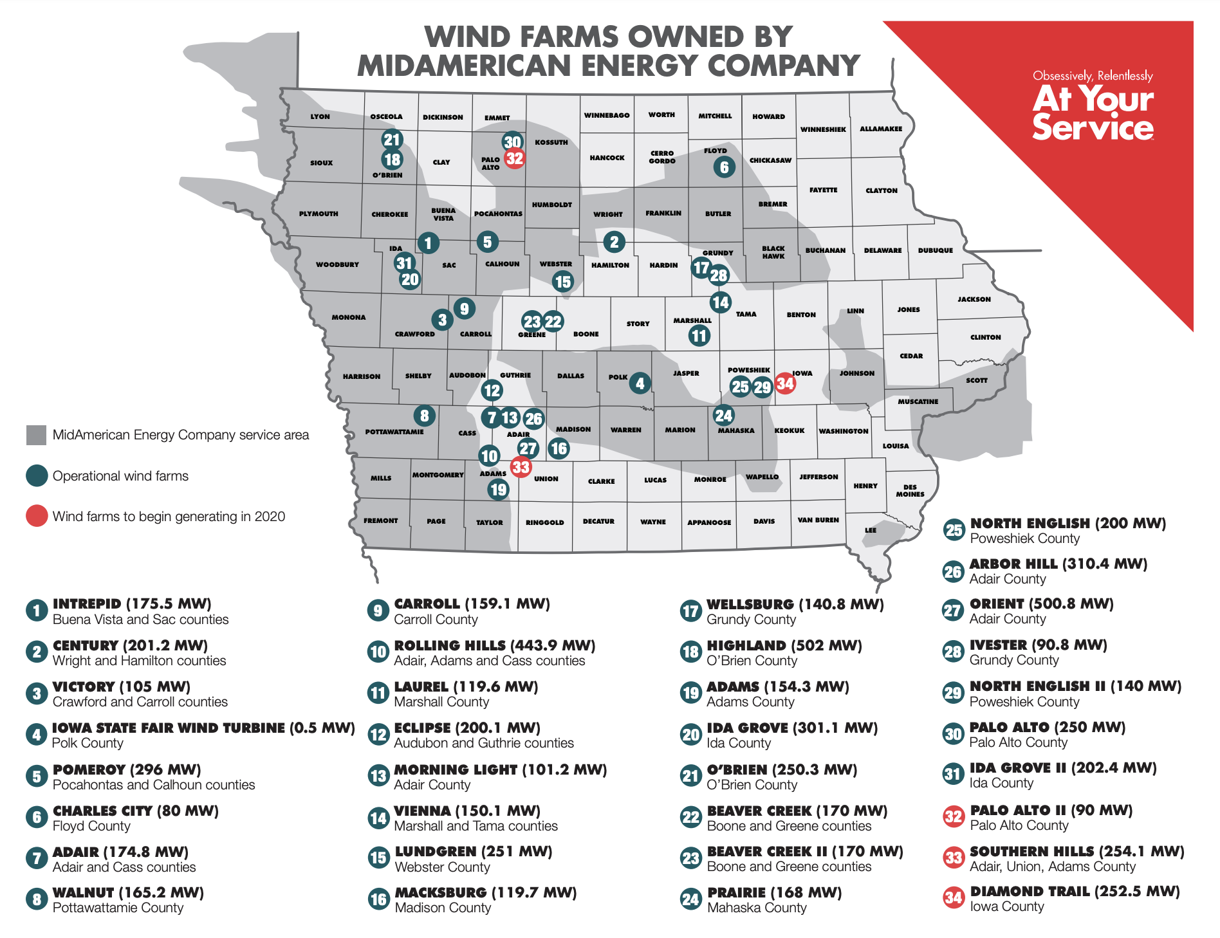
Reference:
https://www.midamericanenergy.com/wind-energy

Agreement between energy companies and landowners:
https://www.wind-watch.org/documents/category/contracts/?titles=on
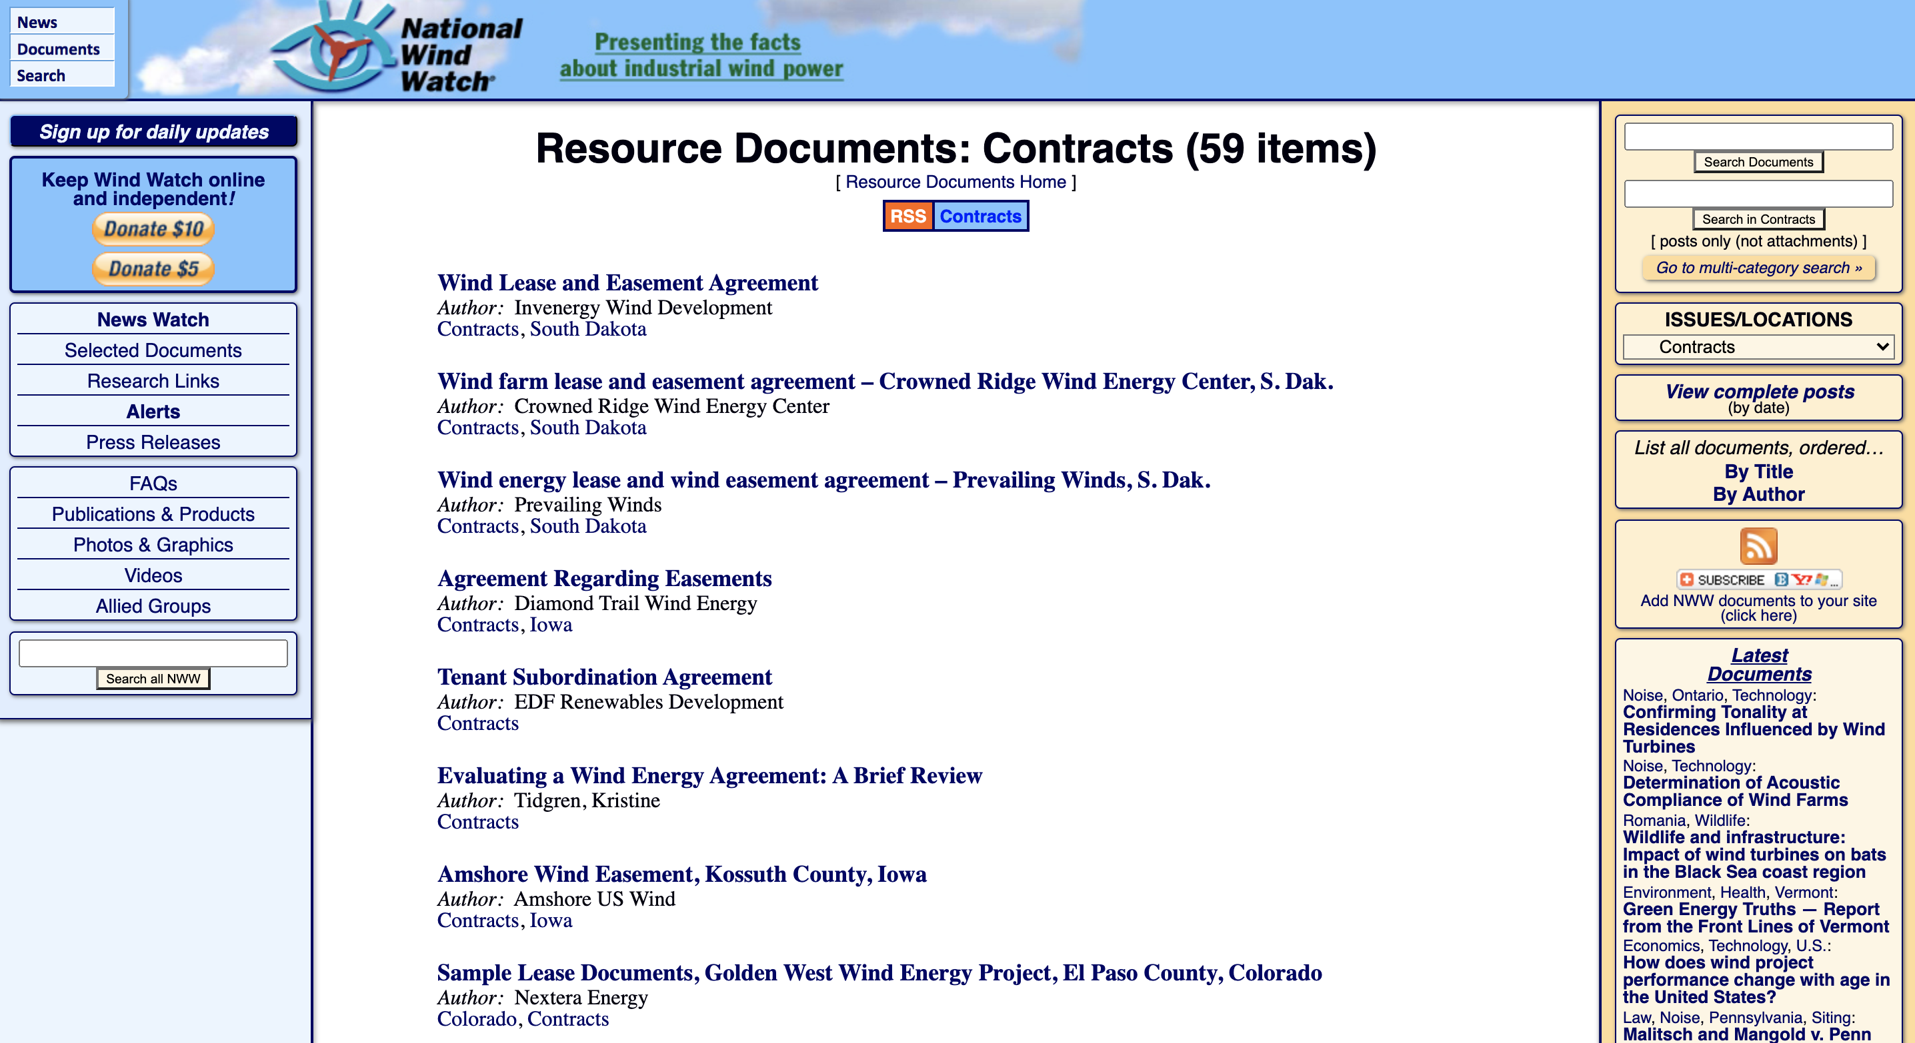

Amshore Wind Easement, Kossuth County, Iowa
1. Easement term: 30 years
2. Permitted use: Install, operate, maintain, remove and replace wind driven, electricity-generating turbine, along with associated blades, tower or mast, support foundation, pad mounted transformer, support structures, conduit, fiber optic communication equipment, cable, poles, materials and any and all related equipment or improvements used, useful, or necessary to allow the Grantee (energy company) to operate such turbine to convert wind resources to electrical energy.
3.
