Probability of losing money.

In the previous meeting, Dr. Min asked me to draw the cumulative graph for the electricity price. Dr. Mackenzie asked me to calculate and draw the total profit of each scenario. Dr. Mackenzie suggested that another way to calculate probability of loosing money. Therefore, in this section I draw the cumulative histogram of electricity price and then I calculate the summation of profit in each scenario and I draw the bar plot of them. I am 99% sure about the accuracy of these materials because I write their code for both parts according to Dr. Min and Dr. Mackenzie’s hints and results look reasonable.

16-1- Cumulative histogram
First, I want to review the following inputs to calculate probabilities:
[R file: electricity price cum.R]
[Excel file which are output of the R code: gbm, newgbm, total profit scenario]
$$dP= μPdt+ σPdz$$
$$P_{t}= P_{0} \exp\left(\left(μ-\frac{1}{2}* σ^{2}\right)*dt+ σ*ε*\sqrt{dt}\right)$$
$μ=0.04$, $σ=0.3$, $t=50 days$, $dt=\frac{1}{50} daily increment$, $P_{0}=131.9 (\frac{\$}{MWh})$
Number of simulations: 50

Graph of GBM simulation of electricity Price:
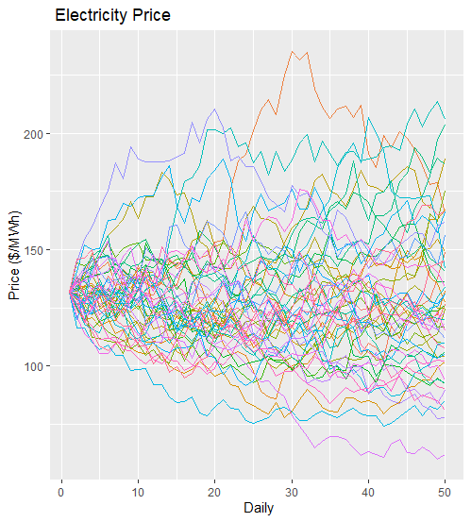

The range of electricity price is 59.82067 ($/MWh) and 235.3123 ($/MWh). Suppose the cost of generation is 110 ($/MWh), if the price is between 110 ($/MWh) and 235.3123 ($/MWh), the generator owner will gain profit and if the price is between 59.82067 ($/MWh) and 110 ($/MWh), the generator owner will lose money.
To calculate the probability of losing money, I want to use the number of times that price is under 110 ($/MWh).
In our example the, the price is less than 110 ($/MWh) in 518 elements from 2500 elements. Therefore:
$$P\left(price≤110\right)=\frac{518}{2500}=0.2072$$
The generator owner will lose money with probability of 0.2072.
Now, I want to show the cumulative histogram of electricity prices. In this order, first I provided the histogram of electricity price in the following:
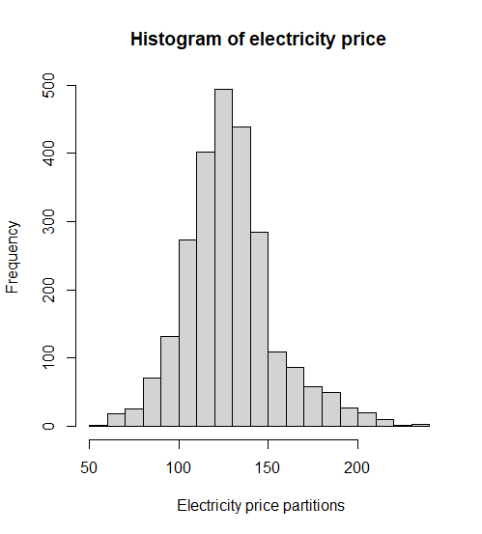
Then I provided the cumulative histogram of electricity prices in the following:
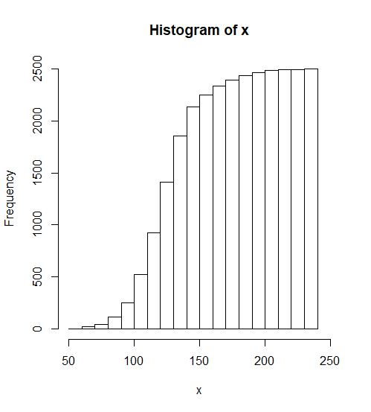
In This graph, each number on X axis shows the specific price and the frequency of that price shows the frequency of prices which are less than that specific price.

16-2- Profit calculations for each scenario
The steps of profit calculations for each scenario:
- Calculate the electricity price for 50 days for 50 scenarios
- Calculate the electricity price minus cost (110 S/MWh) for all elements
- Summation of all profits (negative or positive) for each scenario

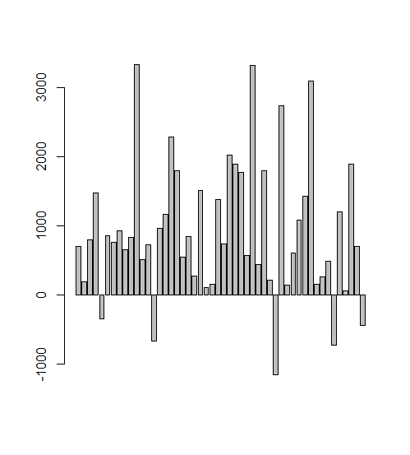
As we can see here, in 5 scenarios the generator owner lose money and in 45 scenarios the generator owner gain profit. Another way to calculate the probability of loosing money according to Dr. Mackenzie will be:
Probability of losing money = 5/45 = 0.11

17- Power meeting (12/15/2020)
In this section, I just run the previous R code with 4 different number of simulations to draw the bar plot and calculate the probability of loosing profit. There is no difference between this section and previous section in aspect of accuracy. You can use previous R file with different number of simulations that I choose to run the program and see the bar plot.

17-1- Profit calculations for each scenario for different number of simulations

In this section I choose the following inputs to calculate probabilities:
$$dP= μPdt+ σPdz$$
$$P_{t}= P_{0} \exp\left(\left(μ-\frac{1}{2}* σ^{2}\right)*dt+ σ*ε*\sqrt{dt}\right)$$
Graph 1:
$μ=0.04$, $σ=0.3$, $t=50 days$, $dt=\frac{1}{50} daily increment$, $P_{0}=131.9 (\frac{\$}{MWh})$
Number of simulations: 50
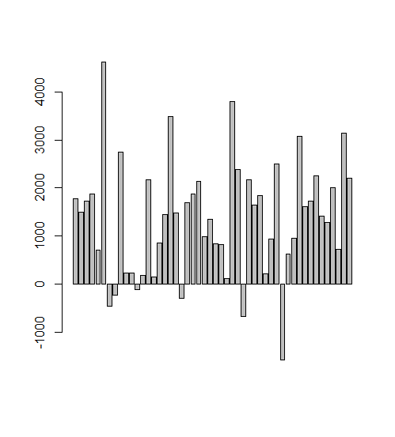
Probability of losing money = 6/50 = 0.12

Graph 2:
$μ=0.04$, $σ=0.3$, $t=50 days$, $dt=\frac{1}{50} daily increment$, $P_{0}=131.9 (\frac{\$}{MWh})$
Number of simulations: 100

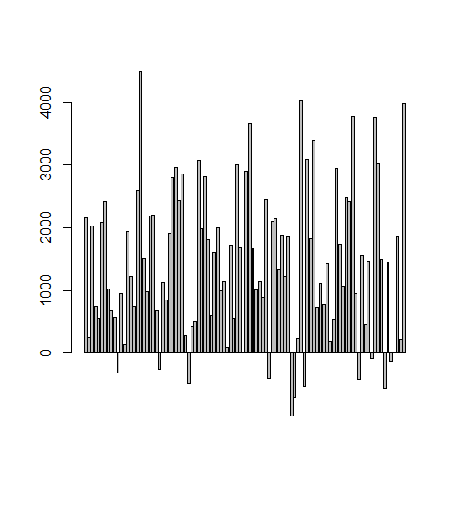
Probability of losing money = 11/100 = 0.11

Graph 3:
$μ=0.04$, $σ=0.3$, $t=50 days$, $dt=\frac{1}{50} daily increment$, $P_{0}=131.9 (\frac{\$}{MWh})$
Number of simulations: 500
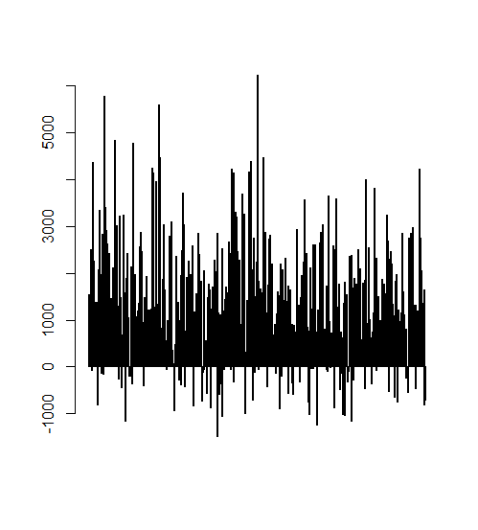

Probability of losing money = 67/500 = 0.134

Graph 4:
$μ=0.04$, $σ=0.3$, $t=50 days$, $dt=\frac{1}{50} daily increment$, $P_{0}=131.9 (\frac{\$}{MWh})$
Number of simulations: 1000
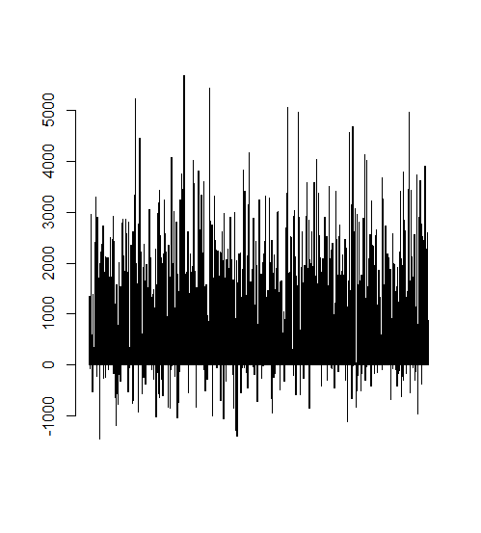
Probability of losing money = 124/1000 = 0.124

AS we can see, the probabilities are very closed together with different number of simulations. The confidence interval for a probability is p +/- z * sqrt(p(1-p)/n) where p is the estimated probability, z is a standard normal at a given confidence level, and n is the number of samples (simulations).
For example if we want to calculate confidence interval with 95% confidence:
$$0.124+ Z_{0.05}* \sqrt{0.124(1-0.124)/1000} <p hat<0.124+ Z_{0.05}* \sqrt{0.124(1-0.124)/1000}$$
$$Z_{0.05}=1.645$$

