Life Cycle Costing and Levelized Cost of Energy

Definition of the life cycle cost
Definition of life cycle costing (LCC): Life cycle costing is an important economic analysis used in the selection of alternatives that impact both pending and future costs. It compares initial investment options and identifies the least cost alternatives for a twenty-year period [4].

Wind farm life cycle costs
Wind farm life cycle costs: A wide variety of costs associated with wind farms; this can be grouped into several life cycle components:
- Capital costs: the fixed costs of instruction including manufacturing, installation and transportation.
- Operation and maintenance costs: annual fixed costs associated with running the farm
- Decommissioning: the cost of taking the plant out of commission, dismantling and remediation [4].
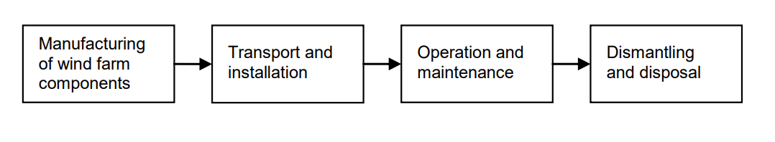
Figure 1 - life cycle of a wind farm

Definition of the levelized cost of energy
Definition of levelized cost of energy (LCOE): levelized cost of energy measures the overall life cycle costs of a technology per unit of electricity produced. It is calculated as the sum of the discounted costs over the generator’s lifetime, spread across the discounted units of energy produced over the lifetime. This requires future costs to be expressed in present value terms by discounting.
The calculation of LCOE requires a substantial number of factors to be determined which can be split into those that determine cost and those that determine energy production. Figure 2 shows the main information that is required to estimate the costs and energy production of a typical wind farm [4].
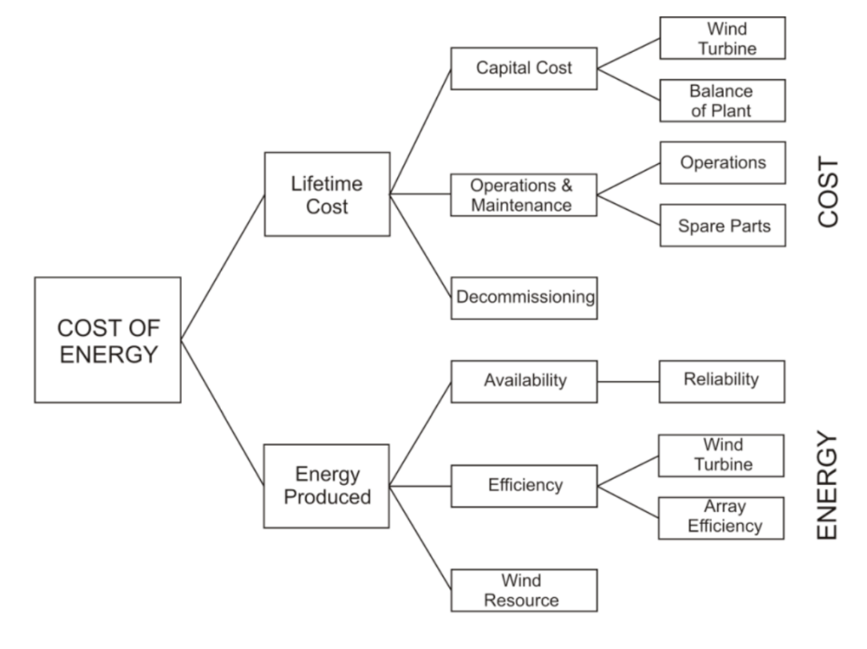
Figure 2 - cost of energy for a wind farm
The LCOE equation can be simplified for each technology. For wind, the following equation is used to calculate LCOE:
$$LCOE= \frac{\left(CapEx*FCR\right)+OpEx}{\left(\frac{{AEP}_{net}}{1000}\right)}$$
LCOE : levelized cost of energy ( $/MWh)
FCR : fixed charge rate (%)
CapEx : capital expenditures ( $/KW)
AEP net : net average annual energy production (MWh / year)
OpEx: operational expenditures ( $/year or KW/year) [5]

Here I provided a conceptual example in LCOE as the following:
LCOE = total cost of ownership ($) / system production over its lifetime ( kWh)
Initial investment = $ 300,000
Maintenance costs = $ 3,000 per year
Estimated yearly production = 182,500 kWh
Project life = 25 years
Lifetime output = 182,500 (kWh/year) * 25 years = 4,562,500 kWh
Total cost of ownership = $ 300,000 + ( $ 3,000 * 25 years) = $ 375, 000
Therefore the LCOE = $ 375, 000 / 4,562,500 kWh = 0.0822 ($/kWh)

Another simplified LCOE formulation is:
$$\frac{\sum_{t=1}^{n}{\frac{I_{t}+ M_{t}+ F_{t}}{{\left(1+r\right)}^{t}}}}{\sum_{t=1}^{n}{\frac{E_{t}}{{\left(1+r\right)}^{t}}}}$$
$I_{t}=$ Investment expenditures in year t
$M_{t}=$ Operations and maintenance expenditures in year t
$F_{t}=$Fuel expenditures in year t
$E_{t}=$ Electricity generation in year t
$r=$ Discount rate
$n=$ Life of the system [6]

The advantages of calculating LCOE:
- Measure value across the longer term, showing projected life cycle cost
- Highlight opportunities to develop different scales of projects
- Inform decisions to pursue projects on an economic basis, compare to utility rates [6]

Variation in estimates
Variation in estimates: There is substantial scope for variation in the estimation of LCOE, which is introduced using different assumptions, methods and uncertainty. These are illustrated in Figure 3 and can be divided into four categories:
- variation in input data arising from the scenarios used, timing and locations, and uncertainty in the data.
- uncertainties introduced by the financial assumptions, arising from location, such as tax rates and treatment, prevailing financial treatments, whether pre-or post-tax rates are used, and adjustments for risk or inflation.
- the physical and temporal boundaries analyzed, and whether specific cost categories are included or not.
- differences in the methodology used, and its intended scope [4]

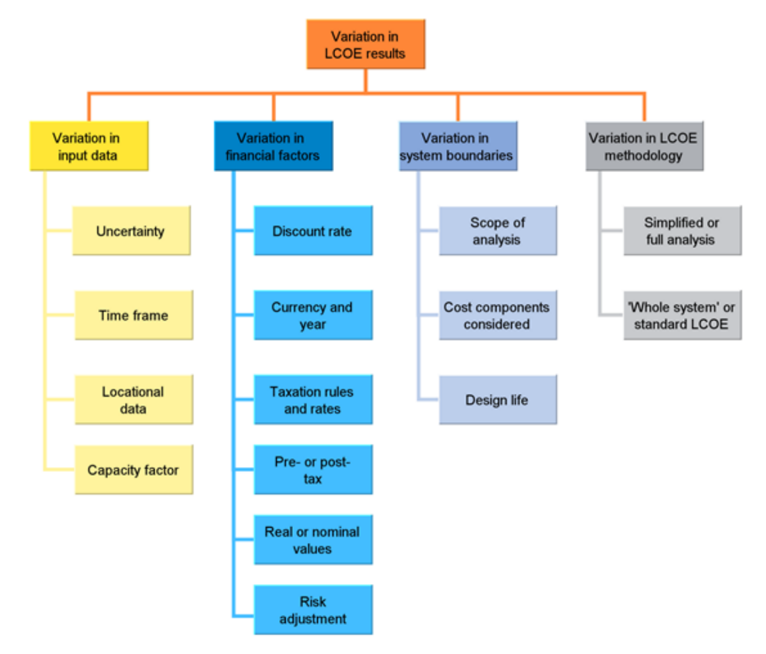
Figure 3 - causes of variation in LCOE in wind farms

Example - Adding a renewable site to node 1

Adding a renewable site to node 1: in this case, I suppose transmission limit in line 1-2 is imposed and the loss on each transmission line is 3 percent of power flow. I want to add a renewable site to the node 1 next to the generator 1. In this regard, besides previous input, there are some new inputs as follows:
- Capital expenditures
- Operational expenditures
- Production quantity $K (MWh)$
Wind tower
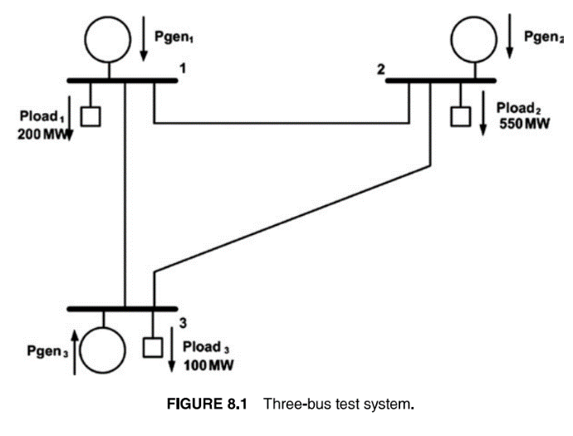
My approach: the load at node 1 is 200 MW, when we add a renewable site there, load 1 is satisfied by both wind towers and generators. I want to consider the case that the 200 MW is split into two parts, the first part will be provided by the renewable site and the second part will be provided by generators.
- Wind tower site (100 MW) – generator (100 MW)
Then, I supposed that the specific value of the 200 MW is provided by the site and I need to calculate and consider the related costs. Then I solve the power system same as before with the remaining load at node 1. After getting the optimal solution using solver, there is some discussions and analysis about costs and locational marginal prices. The most popular land-based turbine is 2.5 MW turbine. This 2.5 MW is called nameplate capacity. In the other words, while wind turbines typically generate electricity during most hours a day, they produce a varying percentage of the nameplate capacity in any given hour. In this regard, we should use from a concept called capacity factor. Capacity factor is a measure of the actual energy produced over a specified period. Capacity factor represents the average generation over time. Capacity factor of wind plants may vary from 20% to 50% depending on turbine type, location, and wind regime.
To provide 100 MW in the renewable site, we need to consider specific number of turbines and capacity factor together. If we consider that capacity factor is 40 %, to provide 100 MW in average we need to follow these series of calculations:
- $100 MW=total nameplate capacity*capacity factor (40 \%)$
$$Total nameplate capacity= \frac{100 MW}{0.4}=250 MW$$
$$number of turbines=\frac{250}{2.4}=104.16$$
- Expected electricity production (expected annual generation or net annual energy production)
$$250 MW*8760 hours*0.4 capacity factor= 876000 MWh$$

Namely energy production:
$$500 MW*8760=2190000 MWh$$

- Capital expenditures is 1470 ($/kW)

- Operational expenditures is 44 ($/kWh)

- Fixed charge rate is a recurring and predictable expense incurred by a firm. Unlike a variable charge, the fixed charge remains the same regardless of the amount of business conducted.
In our example FCR is 7.5%.

- Levelized Cost Of Energy: $LCOE= \frac{\left(CapEx*FCR\right)+OpEx}{\left(\frac{{AEP}_{net}}{1000}\right)}$
- LCOE: levelized cost of energy ($/MWh)
- FCR: fixed charge rate (%)
- CapEx: capital expenditures ($/KW)
- AEP net : net average annual energy production (MWh / year)
- OpEx: operational expenditures ($/kWh)

$LCOE= \frac{105*(\left(1470*0.075\right)+44)}{\frac{876000}{1000}}=$18.48886986 ($/MWh)

So far, I considered that the renewable site is provided 100 MW load at node 1 and it remains 100 MW. Now I want to get the optimal solution for the power system including three generators and three loads at each node.

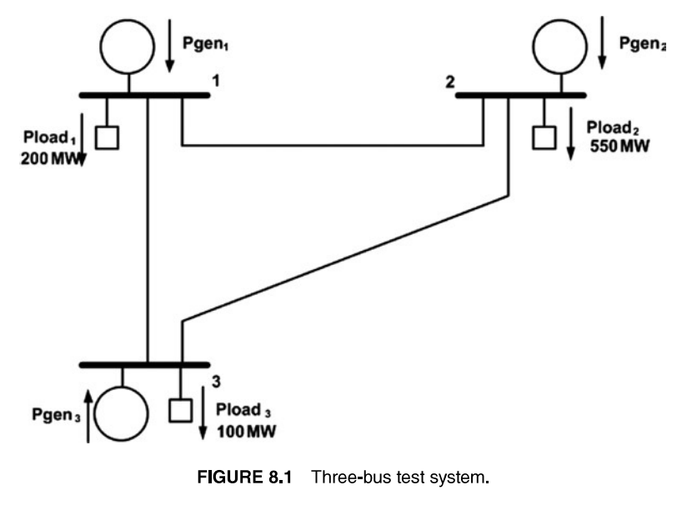
Pload 1
100 MW

I run the excel solver for this new problem and I got this optimal solution.

40 MW
24 MW
110 MW
Pgen3
117.2 MW
Pgen1
400 MW
Pgen1
238.02 MW
Pload 1
100 MW

$P_{1}=238.2 MW$, $P_{2}=400 MW$, $P_{3}=117.2 MW$
$P_{12}=110 MW$, $P_{13}=24 MW$, $P_{32}=40 MW$
$θ_{1}=0$, $θ_{2}=-0.11$, $θ_{3}=-0.03$
In this example because there is transmission limit in one line, the locational marginal price is different at each bus. I calculate locational marginal prices using these equations:
$$F_{i}\left(P_{1}\right)=a+bP_{i}+cP_{i}^{2}$$
$$\frac{dL}{dp_{i}}= b_{i}+2*c_{i}*p_{i}- λ_{i}=0$$
$λ_{1 }=8.66357448 (\frac{\$}{MWh})$, $λ_{2 }=9.402(\frac{\$}{MWh})$, $λ_{3 }=9.099808 (\frac{\$}{MWh})$
$P_{1}+ P_{2}+ P_{1}=755.22$ , $P_{network loss}=5.22$
$P_{ loss12}=3.3$,$P_{ loss13}=0.72$ , $P_{ loss32}=1.2$
$$Total cost=7373.027231 \left(\frac{\$}{h}\right)$$

9-2- Table of summary
 | P1 | P2 | P3 | P12 | P13 | P32 | T loss | Λ1 | Λ2 | Λ3 | Tcost | LCOE
Node 2 | 251.777 | 304.251 | 95.761 | 36.313 | 13.955 | 9.434 | 1.7911 | 8.706 | 9.030 | 8.893 | 6417 | 18.400
Node 1 | 238.02 | 400 | 117.2 | 110 | 24 | 40 | 5.22 | 8.66 | 9.402 | 9.09 | 7373 | 18.48
Case 3 | 332.28 | 396.51 | 126.35 | 110 | 18.42 | 43.48 | 5.15 | 8.95 | 9.38 | 9.18 | 8254

Appendix
