GBM Simulation

In this section, I am going to simulate electricity price as GBM process and compare it with generations’ costs to see if generator owner make money or lose money. In this matter, I choose an example with three nodes, I did the simulation with my own assumptions using R programming and then I calculate costs of generation and finally I compare costs and prices. I am 99% sure about the accuracy of materials in this section. To do the simulation, I searched google and I saw some examples in GBM and I learnt to implement it in R.

13-1- Main example and assumptions
I choose example 8A from power generation, operation and control, chapter 8, page 356. There is a three-bus system with three generators and three loads at three buses. In this system, all of lines are unconstrained and there are no transmission losses in the system. The following figure shows the diagram of three bus system. This is the case 1 of power meeting 5. I just brought the optimal solution and cost function from there.
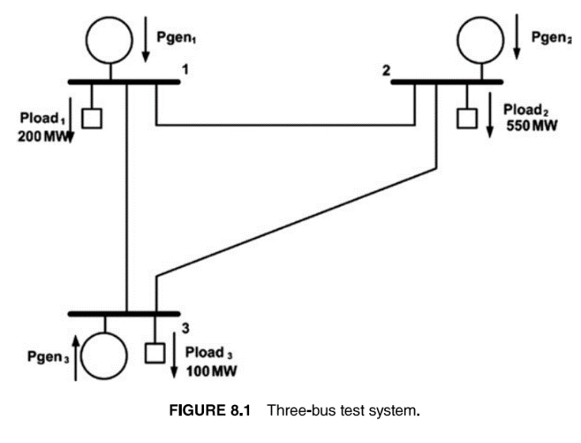
The optimal solution of this problem is:
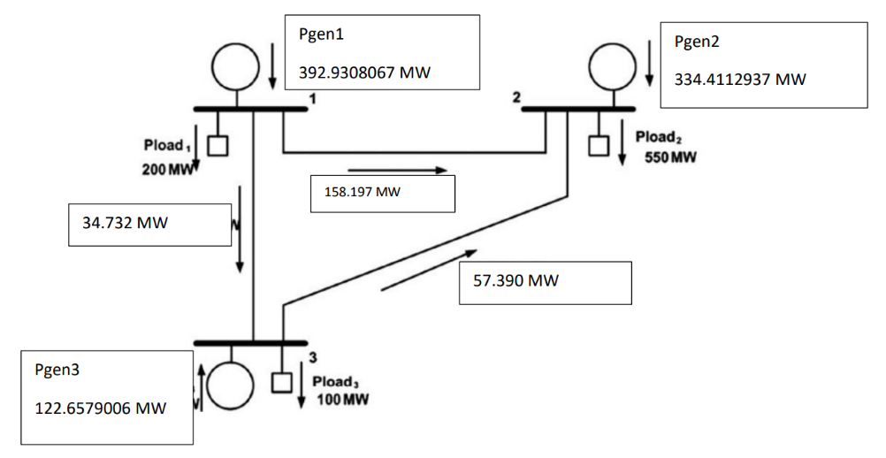

Cost functions of generators:
$$F_{1}\left(P_{1}\right)=561+7.92P_{1}+0.00156P_{1}^{2}=3913.86 (\frac{\$}{h})$$
$$F_{2}\left(P_{2}\right)=310+7.85P_{2}+0.00194P_{2}^{2}= 3135.34 (\frac{\$}{h})$$
$$F_{3}\left(P_{3}\right)=78+7.97P_{3}+0.0048P_{3}^{2}=1127.72 (\frac{\$}{h})$$
These values are gained from case 1 power meeting 5. If you need to review the example, you can refer to the optimal solution of excel output.
Locational marginal prices:
Locational marginal price is $λ=9.147516251 (\frac{\$}{MWh})$ at each bus.
This value gained from case 1 power meeting 5. If you need to review the example, you can refer to the optimal solution of excel output.

Transmission fee:
I considered that each generator should pay 100 ($/MWh) to the line owner. (I choose this value by myself)

13-2- Electricity price as Geometric Brownian motion process
I want to consider that electricity price follows Geometric Brownian Motion process. In the other words, price change process is equal to drift effect (non-random) plus volatility effect (random):
$$dP= μPdt+ σPdz$$
In this equation, $P$ is the electricity price ($/MWh), μ is growth rate of electricity price. $dt$ is the differential period of time, σ is the price volatility, $dz$ is the increment of Wiener process. It means that $dz= ε_{t}\sqrt{dt}$ and $ε \sim N(0, 1)$.
The equation of electricity price at time t is $P_{t}$ :
$$P_{t}= P_{0} \exp\left(\left(μ-\frac{1}{2}* σ^{2}\right)*dt+ σ*ε*\sqrt{dt}\right)$$
Now, I want to run a GBM simulation for electricity price with the following inputs:
$$μ=0.03$$
$$σ=0.2$$
$$t=25$$
$$dt=1/365$$
$$P_{0}=131.9 (\frac{\$}{MWh})$$
Number of simulations: 1000
In the following, I provide the graph of GBM simulation of electricity Price:
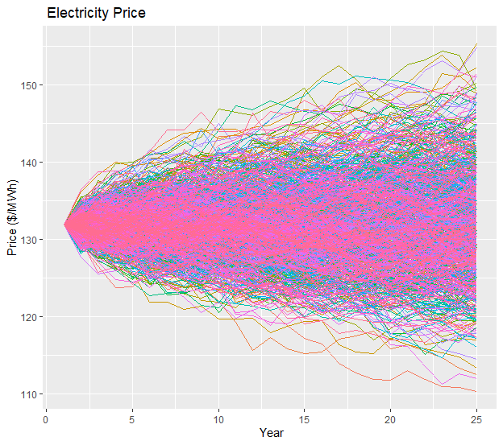
So far, I used GBM simulation to predict electricity price for 25 years. Now, I want to use simulation results to draw distribution of price. In the following I provide the probability distribution of electricity price in 25 years. It seems that the price distribution follows normal distribution.

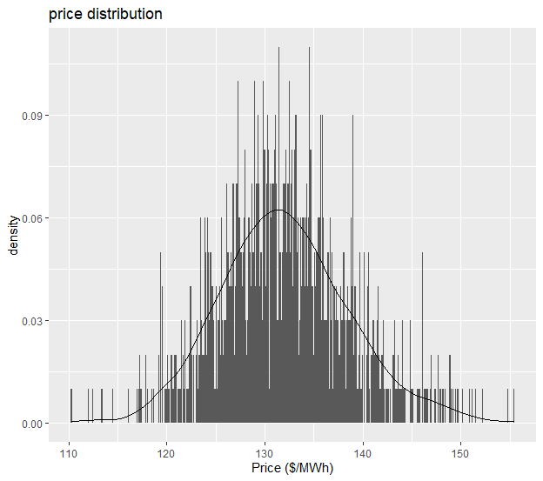
The range of electricity price will be 110 ($/MWh) to 155 ($/MWh)

13-3- Cost calculations for generators
I calculate the cost of generation for each generator by dividing total cost by generation value. For example, 3913.86 is gained by cost function of generator 1 and 392.93 is gained by optimal solution as generation value of generator 1.
Generator 1:
Cost of generation for generator 1 is $\frac{3913.86 (\frac{\$}{h})}{392.93 (MW)}=9.96 (\frac{\$}{MWh})$
Total cost of generation and transmission: $100 \left(\frac{\$}{MWh}\right)+ 9.96 \left(\frac{\$}{MWh}\right)=109.96 (\frac{\$}{MWh})$

Generator 2:
Cost of generation for generator 2 is $\frac{3135.34 (\frac{\$}{h})}{334.41 (MW)}=9.37 (\frac{\$}{MWh})$
Total cost of generation and transmission: $100 \left(\frac{\$}{MWh}\right)+ 9.37 \left(\frac{\$}{MWh}\right)=109.37 (\frac{\$}{MWh})$

Generator 3:

Cost of generation for generator 2 is $\frac{1127.72 (\frac{\$}{h})}{122.65 (MW)}=9.19 (\frac{\$}{MWh})$
Total cost of generation and transmission: $100 \left(\frac{\$}{MWh}\right)+ 9.19 \left(\frac{\$}{MWh}\right)=109.19 (\frac{\$}{MWh})$

13-4- Comparison of costs and price
In all of these three generators’ cost of generations are less than the minimum possible value of price, it means that price minus cost is greater than or equal to zero. So, the generator owner will make money.
Suppose the generation and transmission cost for one generator is the cost of generation and transmission is equal to 120 ($/MWh). In this case if the price is between 120 to 155 ($/MWh), the generator owner will make money, but if the price is between 110 to 120 ($/MWh), the generator owner will lose money.

14- Power meeting (11/24/2020)
In this section, I am going to simulate electricity price as GBM process and compare it with generations’ costs to see if generator owner make money or lose money. In this matter, I choose an example with three nodes, I did the simulation with my own assumptions using R programming and then I calculate costs of generation and then I compare costs and prices and finally I calculated probability of losing money by standard normal distribution. I am 99% sure about the accuracy of materials in this section.

14-1- Main example and assumptions
I choose example 8A from power generation, operation and control, chapter 8, page 356. There is a three-bus system with three generators and three loads at three buses. In this system, all of lines are unconstrained and there are no transmission losses in the system. The following figure shows the diagram of three bus system.
The optimal solution of this problem is:

Cost functions of generators:
$$F_{1}\left(P_{1}\right)=561+7.92P_{1}+0.00156P_{1}^{2}=3913.86 (\frac{\$}{h})$$
$$F_{2}\left(P_{2}\right)=310+7.85P_{2}+0.00194P_{2}^{2}= 3135.34 (\frac{\$}{h})$$
$$F_{3}\left(P_{3}\right)=78+7.97P_{3}+0.0048P_{3}^{2}=1127.72 (\frac{\$}{h})$$
Locational marginal prices:
Locational marginal price is $λ=9.147516251 (\frac{\$}{MWh})$ at each bus.
Transmission fee:
I considered that each generator should pay 100 ($/MWh) to the line owner. (I choose this value by myself)

14-2- Electricity price as Geometric Brownian motion process
(R file: electricity price 2.R)
I want to consider that electricity price follows Geometric Brownian Motion process. In the other words, price change process is equal to drift effect (non-random) plus volatility effect (random):
$$dP= μPdt+ σPdz$$
In this equation, $P$ is the electricity price ($/MWh), μ is growth rate of electricity price. $dt$ is the differential period of time, σ is the price volatility, $dz$ is the increment of Wiener process. It means that $dz= ε_{t}\sqrt{dt}$ and $ε \sim N(0, 1)$.
The equation of electricity price at time t is $P_{t}$ :
$$P_{t}= P_{0} \exp\left(\left(μ-\frac{1}{2}* σ^{2}\right)*dt+ σ*ε*\sqrt{dt}\right)$$
Now, I want to run a GBM simulation for electricity price with the following inputs:
$μ=0.04$ this value is different from previous meeting, I change it by myself with no reason
$σ=0.3$ this value is different from previous meeting, I change it by myself with no reason

$$t=25$$
$$dt=1/365$$
$$P_{0}=131.9 (\frac{\$}{MWh})$$
Number of simulations: 2000 I increase the number of simulations by myself with no reason
In the following, I provide the graph of GBM simulation of electricity Price:
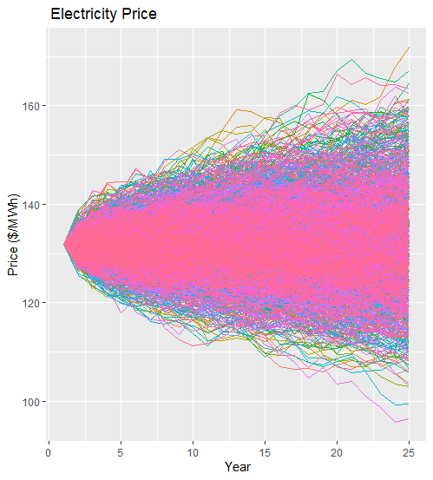

So far, I used GBM simulation to predict electricity price for 25 years. Now, I want to use simulation results to draw distribution of price. In the following I provide the probability distribution of electricity price in 25 years.

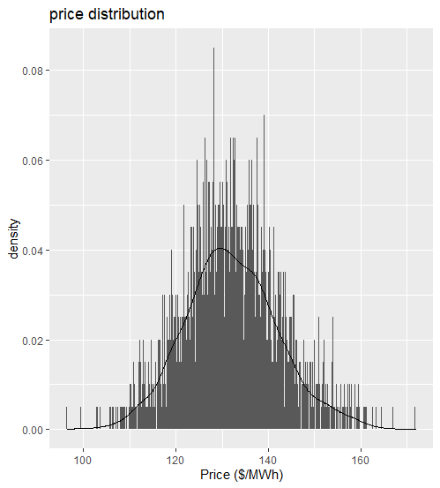
The range of electricity price will be 94 ($/MWh) to 170 ($/MWh)

14-3- Cost calculations for generators
I explain how to calculate the following numbers in previous meeting. Pleas refer to the previous meeting part coast calculations if you have nay question.
Generator 1:
Cost of generation for generator 1 is $\frac{3913.86 (\frac{\$}{h})}{392.93 (MW)}=9.96 (\frac{\$}{MWh})$
Total cost of generation and transmission: $100 \left(\frac{\$}{MWh}\right)+ 9.96 \left(\frac{\$}{MWh}\right)=109.96 (\frac{\$}{MWh})$

Generator 2:
Cost of generation for generator 2 is $\frac{3135.34 (\frac{\$}{h})}{334.41 (MW)}=9.37 (\frac{\$}{MWh})$
Total cost of generation and transmission: $100 \left(\frac{\$}{MWh}\right)+ 9.37 \left(\frac{\$}{MWh}\right)=109.37 (\frac{\$}{MWh})$

Generator 3:

Cost of generation for generator 2 is $\frac{1127.72 (\frac{\$}{h})}{122.65 (MW)}=9.19 (\frac{\$}{MWh})$
Total cost of generation and transmission: $100 \left(\frac{\$}{MWh}\right)+ 9.19 \left(\frac{\$}{MWh}\right)=109.19 (\frac{\$}{MWh})$

14-4- Profit analysis and probabilities
We know that if price – cost > 0 then the generator owner gains profit and if price – cost <0 then the generator owner loses money.
To calculate the probability of losing money of each generator owner, we should transfer the normal distribution of price to normal standard distribution and use this equation:
$$Z \sim N(0, 1)$$
$$P\left(Z ≤z\right)=probability of losing money at specific price$$

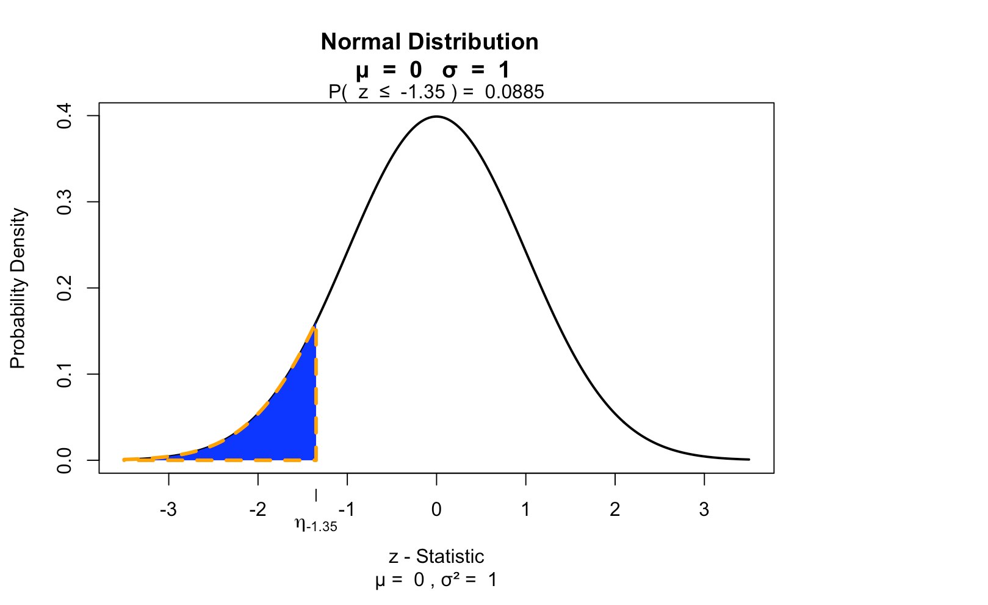

$$Price \sim N(μ=131.9, σ=7.10)$$
Generator 1: $P\left(price≤109.96\right)=P\left(Z ≤\frac{109.96-131.9}{7.10}\right)=P\left(Z ≤ -3.09\right)= 0.001000308$
Generator 2: $P\left(price≤109.37\right)=P\left(Z ≤\frac{109.37-131.9}{7.10}\right)=P\left(Z ≤ -3.17\right)= 0.000753740$
Generator 3: $P\left(price≤109.19\right)=P\left(Z ≤\frac{109.19-131.9}{7.10}\right)=P\left(Z ≤ -3.2\right)= 0.0006905034$

Analysis: The generator 1 owner will lose money with probability of $0.001000308$.
The generator 2 owner will lose money with probability of $0.000753740$.
The generator 3 owner will lose money with probability of $0.0006905034$.

15- Power meeting (12/01/2020)
In the previous meeting I used standard normal distribution to calculate the probability of losing money for generator owner. Dr. Mackenzie suggest another approach to calculate probabilities. He suggested to see how many times the price is less than cost and how many times it is more than cost, then we should calculate the probability of losing money using dividing number of times which price was less than cost by total number of values.
In the second section of this meeting, I calculate daily return for the price series. I am 99% sure about the material of this section because I used reasonable sources and Dr. Min and Dr, Mackenzie hints.

15-1- Another approach to calculate probabilities of losing money
(R file: electricity price 3.R)
In this section I choose the following inputs to calculate probabilities:
$$dP= μPdt+ σPdz$$
$$P_{t}= P_{0} \exp\left(\left(μ-\frac{1}{2}* σ^{2}\right)*dt+ σ*ε*\sqrt{dt}\right)$$
$μ=0.04$, $σ=0.3$, $t=50 days$, $dt=\frac{1}{50} daily increment$, $P_{0}=131.9 (\frac{\$}{MWh})$
Number of simulations: 50

Graph of GBM simulation of electricity Price:
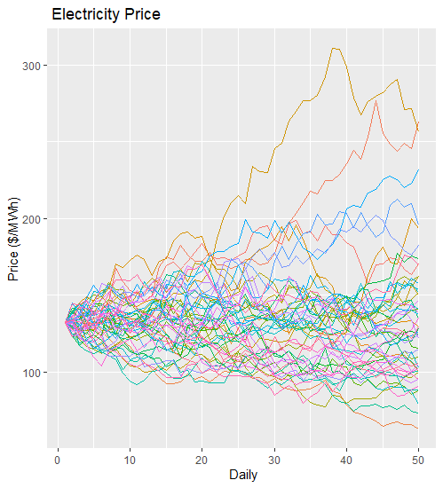
The range of electricity price is 62.44182 ($/MWh) and 311.036 ($/MWh). Suppose the cost of generation is 110 ($/MWh), if the price is between 110 ($/MWh) and 311.036 ($/MWh), the generator owner will gain profit and if the price is between 62.44182 ($/MWh) and 110 ($/MWh), the generator owner will lose money.
To calculate the probability of losing money, I want to use the number of times that price is under 110 ($/MWh).
In our example the, the price is less than 110 ($/MWh) in 495 elements from 2500 elements. Therefore:
$$P\left(price≤110\right)=\frac{495}{2500}=0.198$$
The generator owner will lose money with probability of 0.198.

15-2- Daily return calculations
To calculate daily return, first we need to have particular price series. Toward this goal, we need to calculate the mean of prices of each day from all simulations and consider it as daily price series.
Using this series, daily return is calculated by natural logs of price relatives. To know more about daily return concept and calculation method you can refer to reference [10].
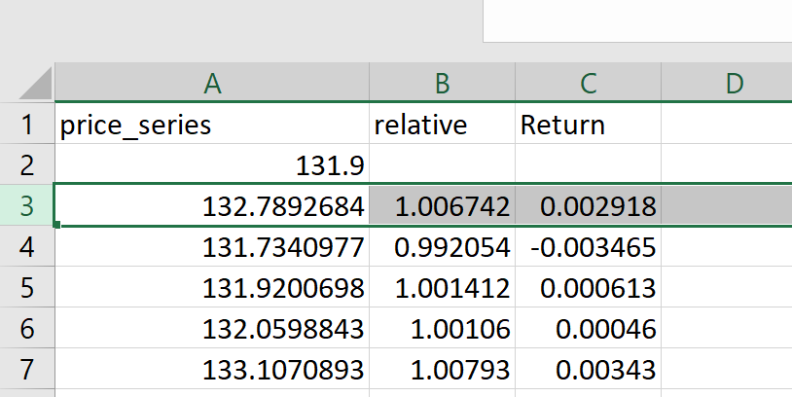

For example, in the following I consider row 2 as day zero, then I provide calculation of relative price change for day 1. After that I provide return day 1 by natural logs of relative price on day 1.

$$relative price change=\frac{132.7892684}{131.9}=1.006742$$
$$return day 1= \log_{10}{1.006742}=0.002918$$
In the following I provide complete information for 50 days such as: price_series, relative change and daily return. Excel file with name of price_series which is produced by R file (electricity price 3.R) is provided.
