**Compendium**

**Excel model**

**Without adding generator 1 (Case 1) –**

**Load – 200MW**

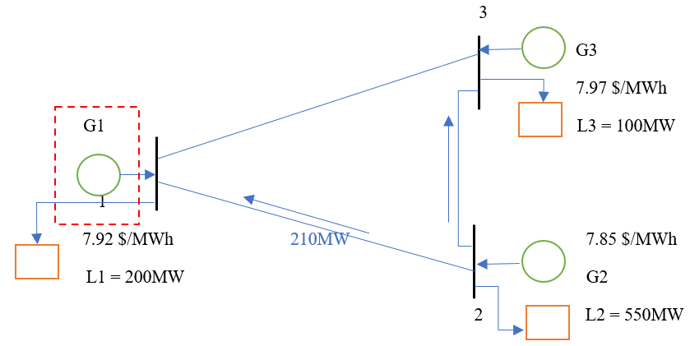

**Input**

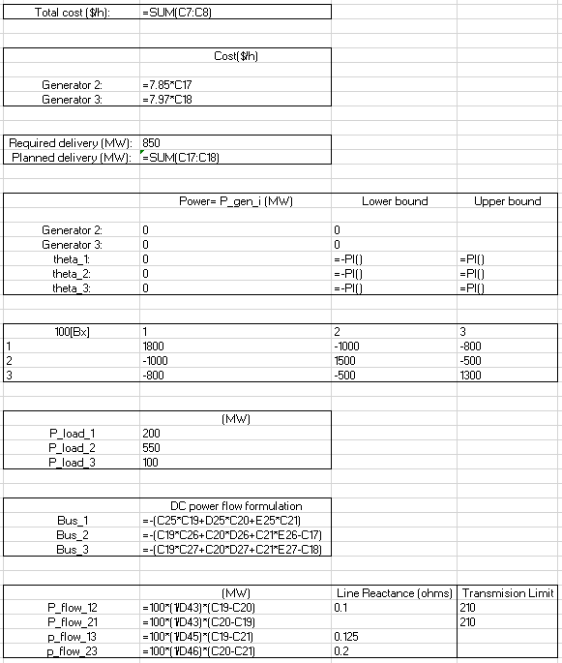

**Output**

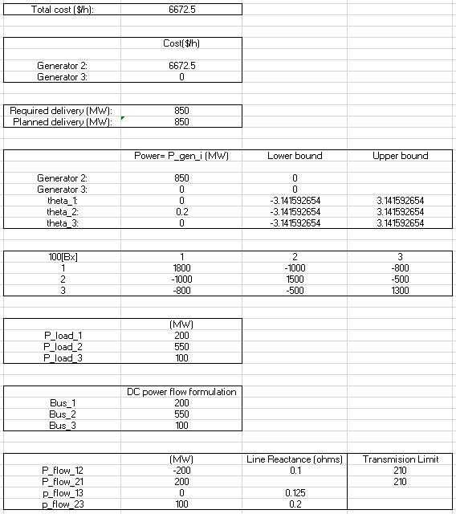

**Sensitivity result -**

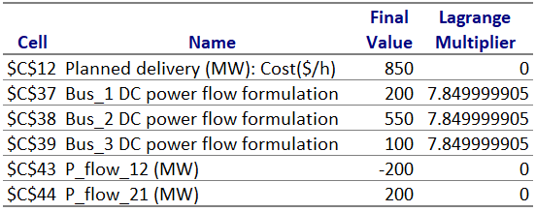

**Load – 148.2 MW**

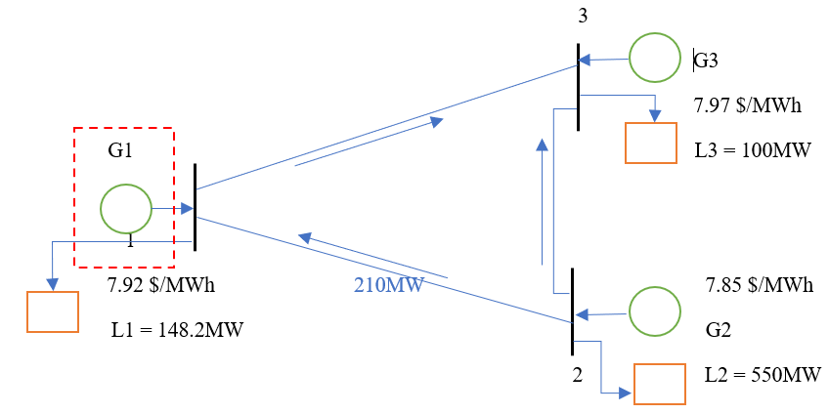

**Input**

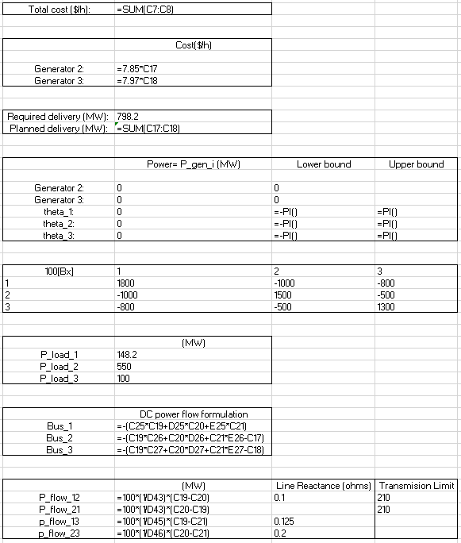

**Output**

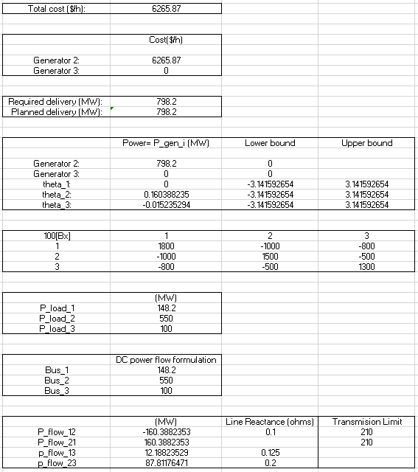

**Sensitivity result –**

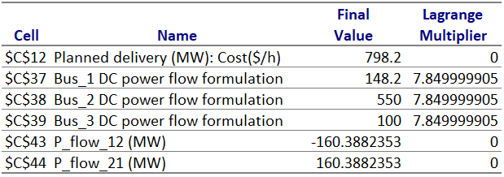

**Load – 270 MW**

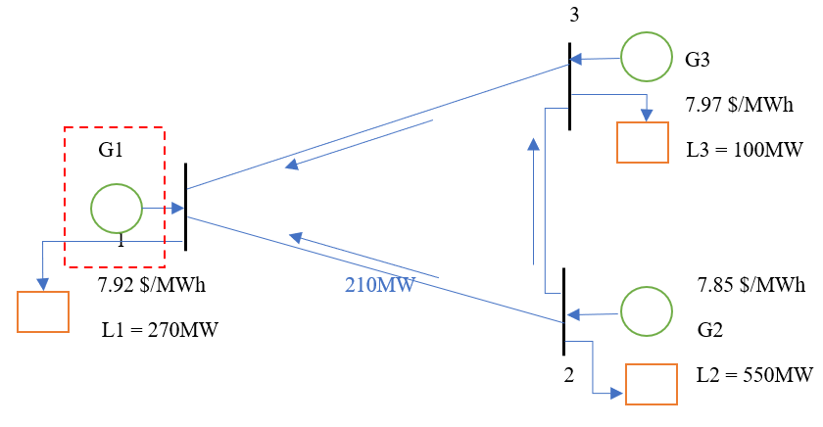

**Input**

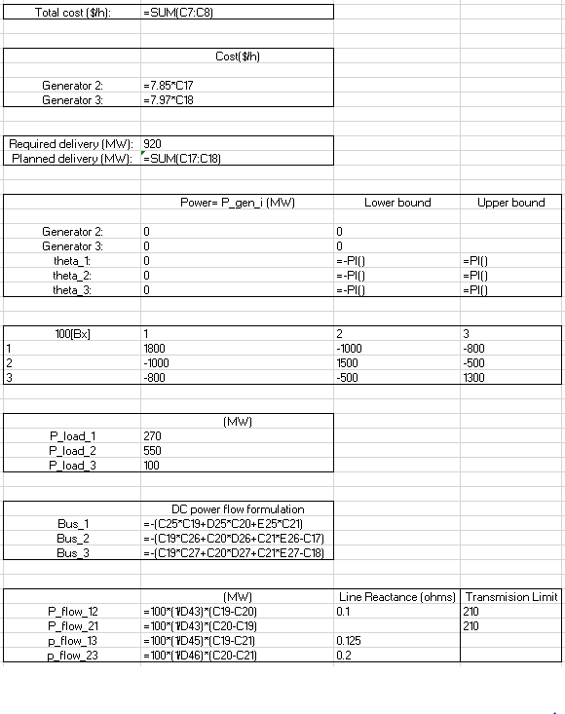

**Output**

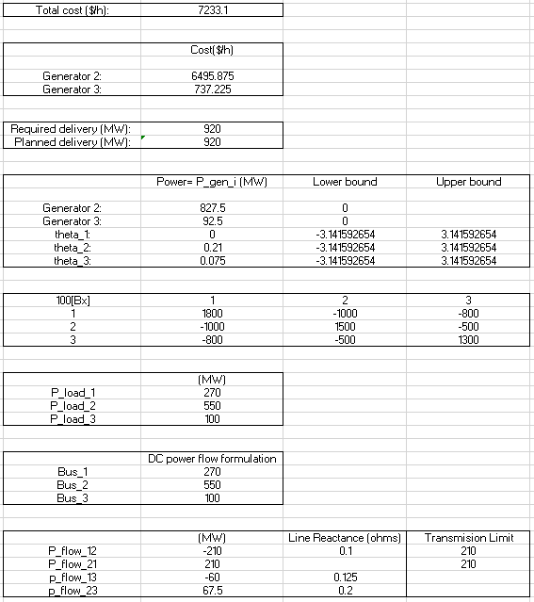

**Sensitivity result –**

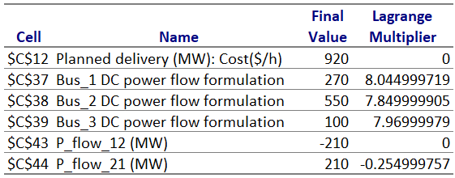

G2 produces 827.5 MW and supplies 550 MW to node 2, 210 MW to node 1 and 67.5 MW to node 3. The demand at node 2 is satisfied completely by G2. Node 3 receives 67.5 MW from G2 and G3 produces 92.5 MW. 100 MW is supplied to node 3’s demand. Remaining 60 MW is supplied to node 1. Node 1 gets 210 MW from node 2 and 60 MW from node 3 to satisfy the demand of 270 MW.

**With generator 1 added (Case 2)-**

**Load – 200MW**

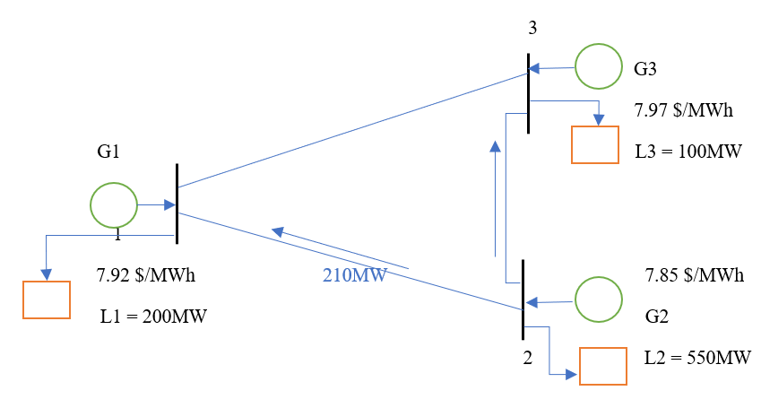

**Input**

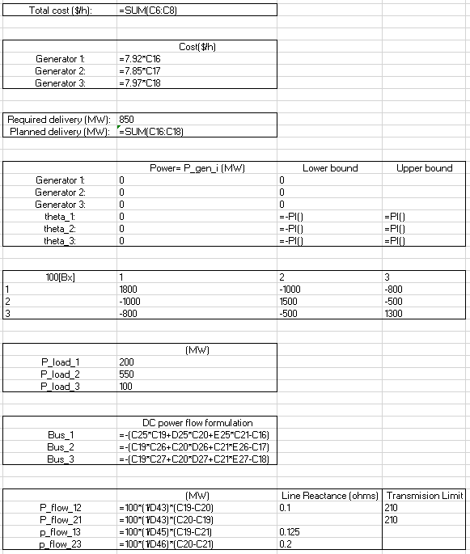

**Output**

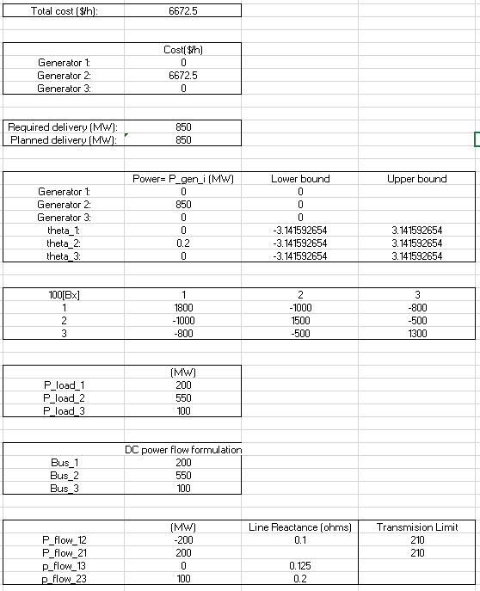

**Sensitivity result –**

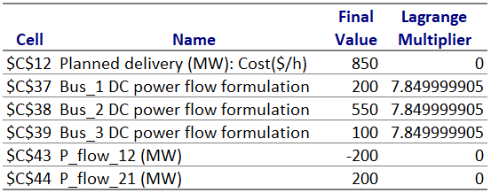

**Load – 148.2 MW**

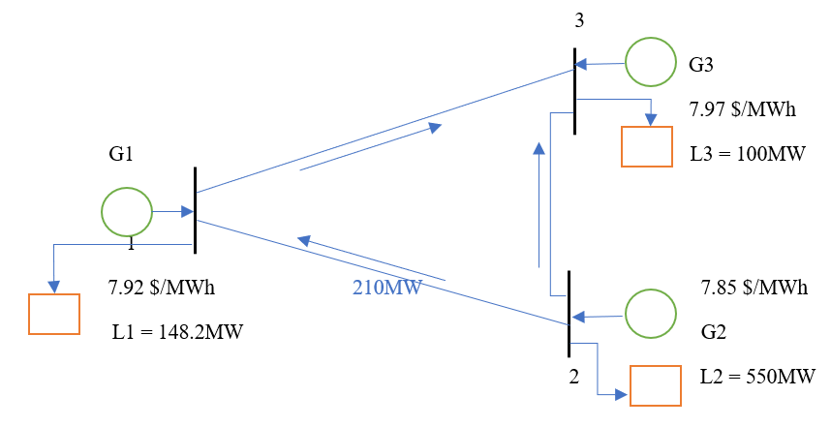

**Input**

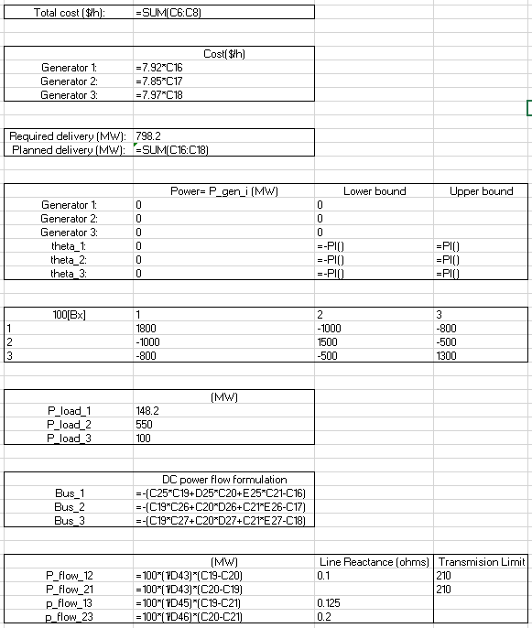

**Output**

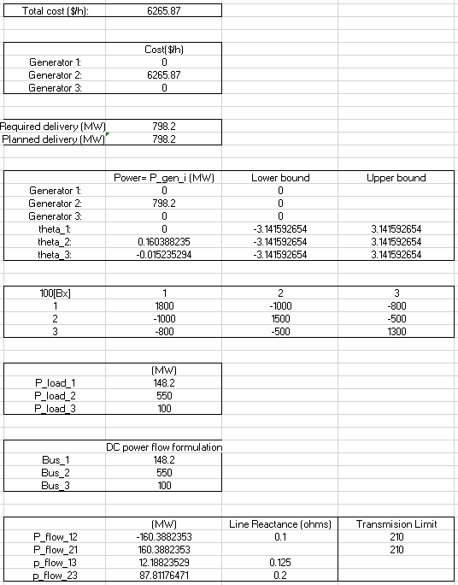

**Sensitivity result –**

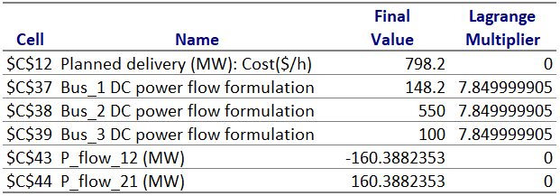

**Load – 270 MW**

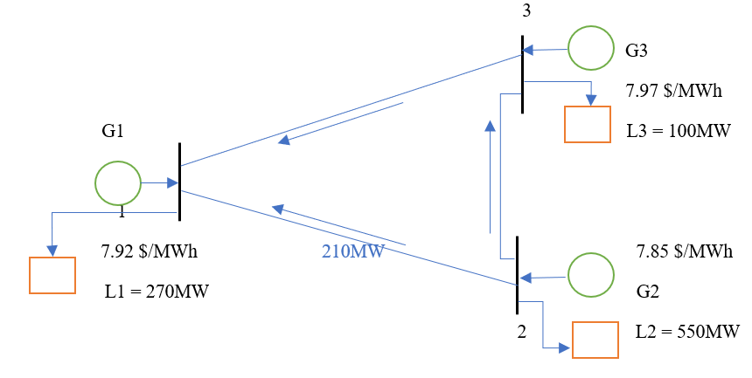

**Input**

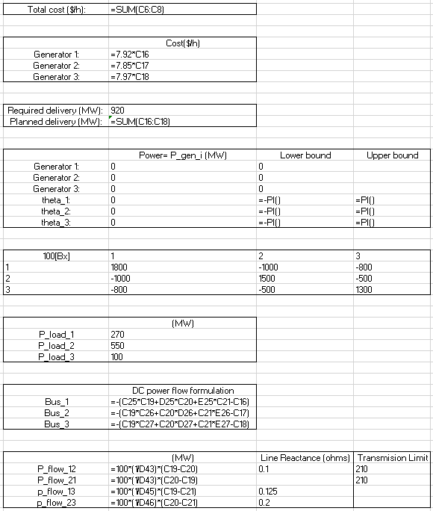

**Output**

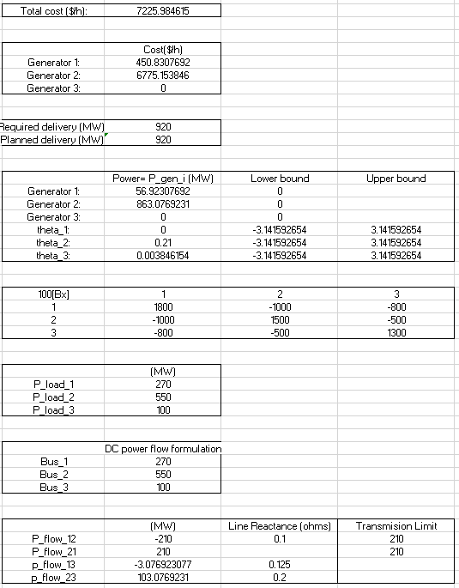

**Sensitivity result**

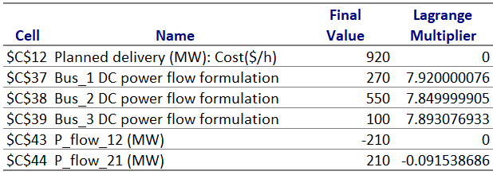

G2 produces 863.07 MW and supplies 550 MW to node 2, 210 MW to node 1 and 103.07 MW to node 3. The demand at node 2 is satisfied completely by G2. Node 3 receives 103.07 MW from G2. 100 MW is supplied to node 3’s demand. Remaining 3.07 MW is supplied to node 1. Node 1 gets 210 MW from node 2 and 3.07 MW from node 3 and G1 produces 56.92 MW to satisfy the demand of 270 MW.