Assessment and Evaluation of Objectives and Outcomes for Continuous Improvement of an Industrial Engineering Program

K. Jo Min, John Jackman, Doug Gemmill
Department of Industrial and Manufacturing Systems Engineering, 3004 Black, Iowa State University, Ames, IA 50011, USA
Email: jomin@iastate.edu (K. Jo Min); IMSE Working Paper (2012)

ABSTRACT
In recent years, ABET accreditation has placed a heavy emphasis not only on the assessment of objectives and outcomes, but also on the evaluation of them and subsequent continuous improvement efforts based on such evaluation. Currently, a plethora of assessment tools and conceptual frameworks notwithstanding, there exists a relative paucity of documented efforts on the actual evaluation and subsequent continuous improvement. In this paper, we first concretely (1) show how such assessment and evaluation can be deliberately and systematically conducted in the context of an Industrial Engineering program. We then (2) show how the results of the objectives evaluation lead to the continuous improvement efforts through the student outcomes. Through (1) and (2), we enable others to specifically identify and prepare for the critical stages necessary to advance beyond a display of assessment tools and conceptual frameworks and to actually close the loop for a continuous improvement cycle.

Keywords:

1. Introduction

Among engineering programs throughout the USA as well as increasingly among non-US programs, ABET accreditation has often become a mandatory minimum standard that must be maintained [1]. At the same time, ABET accreditation has been focusing not only on the assessment of objectives and outcomes of engineering programs, but also on the evaluation of them and the subsequent continuous improvement efforts based on such evaluation [2].
In practice, however, there exists a plethora of assessment tools and conceptual frameworks (see e.g., [3], [4]) and a relative paucity of documented efforts on the actual evaluation and subsequent continuous improvement (see e.g., [5]).
Under these circumstances, it is highly desirable to document step by step how the ABET expectations can be met so that various accreditation stakeholders may be able to specifically identify and prepare for the critical stages necessary to advance beyond assessment tools and conceptual frameworks and to close the loop for a continuous improvement cycle.
In particular, ABET specifically asks [6] to
1. document your processes for regularly assessing and evaluating the extent to which the program educational objectives and student outcomes are being attained.
2. document the extent to which the program educational objectives and student outcomes are being attained.
3. describe how the results of these processes are being utilized to effect continuous improvement of the program.
In this paper, in view of these expectations, we aim to contribute by actually demonstrating how each of these expectations can be met step by step in the context of an Industrial Engineering program (see e.g., [7] in the context of environmental sustainability education and [8] in the context of international supply chain education).
In so doing, we hope to bridge the gap between the plethora of abstract frameworks and the paucity of documented practices – a little bit at a time. By documenting such practice, we also hope to stimulate the discussion in this important area of the outcome and objective assessment and evaluation as well as the subsequent continuous improvement efforts. Ultimately, we hope all such activities will positively contribute toward better learning experiences by the students in engineering programs.
Methodology-wise, our responses to these expectations heavily depend on a series of gap analyses (see e.g., [9]) and exploit triangulations for robustness of our findings (see e.g., [10]). In so doing, for example, it will be clear that the identification of the areas for improvement will be systematic and deliberate. It will also be clear that the pieces of evidence supporting our findings will come from different assessment methods and from different stakeholders.
Hence, it is also hoped that others would be able to understand and rely on such gap analyses and triangulations for results that are not haphazardly obtained/attained, and further facilitate discussion and exchange of ideas on the methodology side as well.
The rest of the paper is organized as follows. In Section 2, we present the IE program background, program educational objectives (PEO’s), and student outcomes, and show how they are related. Next, in Section 3, we present how the assessment and evaluation of the objectives can be systematically conducted. In Section 4, for student outcomes, we show how the assessment and evaluation are conducted. This is followed by Section 5, presenting how the results of the PEO’s evaluation of lead to the improvement efforts through the student outcomes. Finally, in Section 6, we make concluding remarks and comment on relevant future endeavors.

2. Program Educational Objectives and Student Outcomes

Iowa State University (ISU) is a land-grant institution with obligations to teach practical classes that will provide students with the knowledge to make a difference in the world. This ISU mission provides a clear vision for an educational philosophy that matches closely the goals of undergraduate college of engineering – provide students with the kind of training that will allow them to make a difference in our state, nation and around the world. To achieve this mission, the Industrial Engineering (IE) program for the Bachelor of Science (BS) degree must be responsive to the needs of relevant industries such as manufacturing and services. Hence, feedback from the relevant industries, alumni, and current students who often have co-op and internship experiences provide information that should be used to improve our programs through continuous improvement efforts.
As one can observe subsequently, this ISU mission-based philosophy deeply influences the assessment and evaluation processes of the IE educational program objectives (PEO’s) and student outcomes as well as the IE program continuous improvement process. In what follows, we describe the PEO’s, student outcomes, and their relationships.

2.1 Program Educational Objectives
The IE Program educates its future graduates to accomplish its educational objectives in their early careers. Specifically, the IE curriculum prepares its majors so that, within a few years after graduation, graduates’ attainments are
1. industrial engineering decisions that result in well-reasoned, value-added solutions.
2. communications with stakeholders that are informative, persuasive, and constructive.
3. contributions to team goals through effective team interactions and leadership.
4. new skills and knowledge that advance professional practice and enable career advancement.
We note that these objectives deliberately and systematically support the ISU mission as they not only emphasize the technical achievements, but also professional practice-related achievements in communications, teamwork, and continual learning by our alumni.
The primary constituencies of the program and how they relate to it are: 1. Faculty, 2. Students, 3. Alumni, and 4. Industries. We do note that there are other stakeholders (but not the primary constituencies) such as the university administrators, as well as professional societies and other relevant organizations such as the Institute of Industrial Engineers (IIE) and ABET.

2.2 Student Outcomes
The IE Program has the following student outcomes.
(a) an ability to apply knowledge of mathematics, science, and engineering
(b) an ability to design and conduct experiments, as well as to analyze and interpret data
(c) an ability to design a system, component, or process to meet desired needs within realistic constraints such as economic, environmental, social, political, ethical, health and safety, manufacturability, and sustainability
(d) an ability to function on multidisciplinary teams
(e) an ability to identify, formulate, and solve engineering problems
(f) an understanding of professional and ethical responsibility
(g) an ability to communicate effectively
(h) the broad education necessary to understand the impact of engineering solutions in a global, economic, environmental, and societal context
(i) a recognition of the need for, and an ability to engage in life-long learning
(j) a knowledge of contemporary issues
(k) an ability to use the techniques, skills, and modern engineering tools necessary for engineering practice
(l) an ability to design, develop, implement, and improve integrated systems that include people, materials, information, equipment and energy
(m) an ability to provide leadership in multi-functional teams.
We note that Outcomes (a) through (k) are the ABET specified outcomes. We also note that there are two additional outcomes articulated by our program: Outcome (l) and Outcome (m). Both of them are determined by the department faculty, but Outcome (l) is in part inspired by the Industrial Engineering Program Criteria while Outcome (m) is in part inspired by the IE Industry Advisory Council (IAC).

2.3 Relationship of Student Outcomes to Program Educational Objectives
We first show how the student outcomes specifically prepare graduates to attain the program educational objectives, and summarize their relationships in Table 1 as follows.

2.3.1 Objective 1: Industrial engineering decisions that result in well-reasoned, value-added solutions.
In order to prepare our graduates to attain this objective, it is necessary that our students obtain the technical skills and knowledge specified in Outcomes (a), (b), (c), (e), (k), and (l). Also, obtaining Outcomes (h) and (j) will facilitate reaching well-reasoned, valued-added solutions. We note that the remaining outcomes not mentioned here will also contribute positively toward this objective, but with less direct relationships and perhaps less impact. This note is applicable equally to all other objectives.

2.3.2 Objective 2: Communications with stakeholders that are informative, persuasive, and constructive
In order to prepare our graduates to attain this objective, it is necessary that our students obtain the skills and knowledge specified in Outcome (g). Also, Outcomes (d) and (m) provide some of the best preparations to achieve this objective – context and industry practice-wise. We believe Outcome (h) will strongly support the achievement of this objective.

2.3.3 Objective 3: Contributions to team goals through effective team interactions and leadership.
In order to prepare our graduates to attain this objective, it is necessary that our students obtain the abilities specified in Outcomes (d) and (m). Also, Outcome (g) provides some of the best preparation to achieve this objective – skill and knowledge-wise. Furthermore, we believe Outcome (f) is essential for the sustainable attainment of this objective.

2.3.4 Objective 4: New skills and knowledge that advance professional practice and enable career advancement.
In order to prepare our graduates to attain this objective, it is necessary that our students obtain the recognition and ability specified in Outcome (i). Also, Outcome (j) will facilitate the achievement of this objective by supplying appropriate and relevant information on contemporary (not stale or obsolete) issues. Furthermore, we believe that in the long run, Outcome (f) is essential for the advancement of professional practices as well as careers.

2.3.5 Mapping of Objectives to Outcomes
The following table summarizes the mapping of the 4 program educational objectives to the 13 student outcomes.
Objective/Outcome | a | b | c | d | e | f | g | h | i | j | k | l | m
1 | x | x | x |  | x |  |  | x |  | x | x | x
2 |  |  |  | x |  |  | x | x |  |  |  |  | x
3 |  |  |  | x |  | x | x |  |  |  |  |  | x
4 |  |  |  |  |  | x |  |  | x | x

Table 1 Mapping of objectives to outcomes

So far, we have presented the IE program background, PEO’s, and student outcomes, and showed how they are related. Next, we show how the evaluation of the objectives is systematically conducted.

3. Assessment and Evaluation of Program Educational Objectives

The assessment and evaluation process is as follows. With the primary constituencies of the faculty, alumni, and industries in mind, we first design a survey that asks, for each program educational objective,
“To what extent have BSIE graduates attained the following program educational objectives?”
“How necessary are the following program educational objectives for the BSIE graduates?”
“How well has the BSIE Program at ISU prepared its graduates to attain the following program educational objectives within a few years of graduation?
The constituents are asked to provide a numerical score for each objective between 1 (not at all) to 5 (very much/well).
With the primary constituency of the students, on the other hand, we design a similar survey that excludes the first type of question on attainments as these attainments are years away.
For the faculty, each faculty member is given the survey form. At the same time, Year 1 alumni (those who graduated last year) and Year 3 alumni (those who graduated 3 fiscal years ago), representing the alumni, are given the survey forms. Also, each member of the industry advisory council, representing the industries, is given the survey form. As for the students, each member of the student focus group is given the survey form. We note that the student focus group consists of more mature students with leadership experiences such as peer mentors, student ambassadors for recruiting, and learning community assistants for retention. We do recognize that the students’ input should be a valuable component in the objective assessment and evaluation process. At the same time, some students (e.g., often 18 years old) may not be in a best position to answer questions regarding the program graduates’ achievements 3 to 5 years after graduation. Hence, we are attempting to strike a balance here by treating the student focus group as the proxy for the students.
We note that the surveys are conducted almost simultaneously to enhance the validity of the cross-checking across the primary constituencies later (cf. one constituency asked 2 years ago while another this year). We further note that there are additional entry points for input and feedback. Namely, faculty meetings as well as industrial advisory council meetings where bi-directional questions and answers are possible. We also note that we are mindful of students’ input revealed in various feedback mechanisms ranging from written comments in graduating senior surveys and oral comments during student focus group meetings.
We note that the current evaluation process, as we conducted in Spring 2011, starts every three years with the revised program educational objectives (if a revision is needed) within six months or so. Also, we note that the old evaluation process, as we conducted during Fall 2008-Spring 2009, started every four years with the revised program educational objectives within twelve months or so (Hence, the preceding evaluation was conducted during Fall 2004-Spring 2005, which were before the last general review). With these changes, we aim to coincide better with the university-wide changes in its catalog (e.g., from 2-year catalogs to 1-year catalogs, submission deadlines less well in advance, towards elimination of paper copies, etc.).
We now proceed to discuss our expectation and results in the following two subsections.

3.1 The Expected Level of Attainment for the Program Educational Objectives
Even though we do not have a single number from a single constituency that will assure the attainment of each program educational objective, we expect that, for each program educational objective, a satisfactory level of attainment is achieved if the average numerical scores from the faculty, alumni, and industries are all higher than 3 (5 best/1 worst) concurrently. By cross-checking the independent returns of the three primary constituencies of the faculty, alumni, and industries, we believe that our conclusion is robust and entirely plausible as the possibility of all three constituencies coincidently being wrong is remote. The actual (cf. expected) levels of attainment will be elaborated in the next subsection.

3.2 Results of Program Educational Objectives Assessment and Evaluation
The results from the returned survey forms are summarized as follows.
Average Score  5=Best | Faculty | Alumni |  | Industry  (Advisory Council) | Student  (Focus Group)
Average Score  5=Best | Faculty | Year 1 | Year 3 | Industry  (Advisory Council) | Student  (Focus Group)
Attainment
A.1 | 4.31 | 4.09 | 4.28 | 4.20 | NA
A.2 | 3.54 | 3.82 | 4.56 | 3.80 | NA
A.3 | 4.15 | 4.45 | 4.67 | 4.40 | NA
A.4 | 4.15 | 4.18 | 4.22 | 3.60 | NA
Necessity
B.1 | 5.00 | 4.82 | 4.28 | 4.57 | 4.36
B.2 | 4.69 | 4.82 | 4.67 | 4.86 | 4.30
B.3 | 4.69 | 4.91 | 4.78 | 4.57 | 4.73
B.4 | 4.85 | 4.91 | 4.44 | 4.29 | 4.73
Preparation
C.1 | 4.46 | 3.91 | 4.50 | 4.20 | 3.91
C.2 | 3.46 | 3.82 | 4.17 | 3.60 | 3.60
C.3 | 3.69 | 4.09 | 4.50 | 4.40 | 4.36
C.4 | 4.15 | 4.00 | 4.17 | 3.80 | 4.18

Table 2 Average scores of each objective for each constituency

We note that the categories A, B, and C represent the attainment, necessity, and preparation, respectively. We also note that there are four aforementioned objectives for each category of questions. We further note that the number of respondents for the faculty, Year 1 alumni, Year 3 alumni, industry advisory council, and student focus group are 13, 11, 18, 7, and 11, respectively. Finally, the standard deviations range from 0 (the necessity of Objective 1 according to the faculty) to 1.22 (the preparation for Objective 1 according to the Year 1 alumni).
From Table 2, we easily observe that the average numerical scores from the faculty, alumni, and industries are all higher than 3 concurrently. In fact, the absolute majority of the average numerical scores are 4 or even higher. Hence, we conclude that each objective is satisfactorily attained at this point in time. Furthermore, we note that, collectively, the rows of A.1, A.2, A.3, and A.4 indicate the actual extent of the attainment for the program educational objectives 1, 2, 3, and 4, respectively.
As we have concurrently conducted the survey across the four primary constituencies, a gap analysis is visually conducted as follows. Fig. 1 plots the average numerical scores from the faculty, Year 1 alumni, Year 3 alumni, and the industry advisory council for each objective (the objective number follows the constituency symbol) vs. attainment, necessity, and preparation.
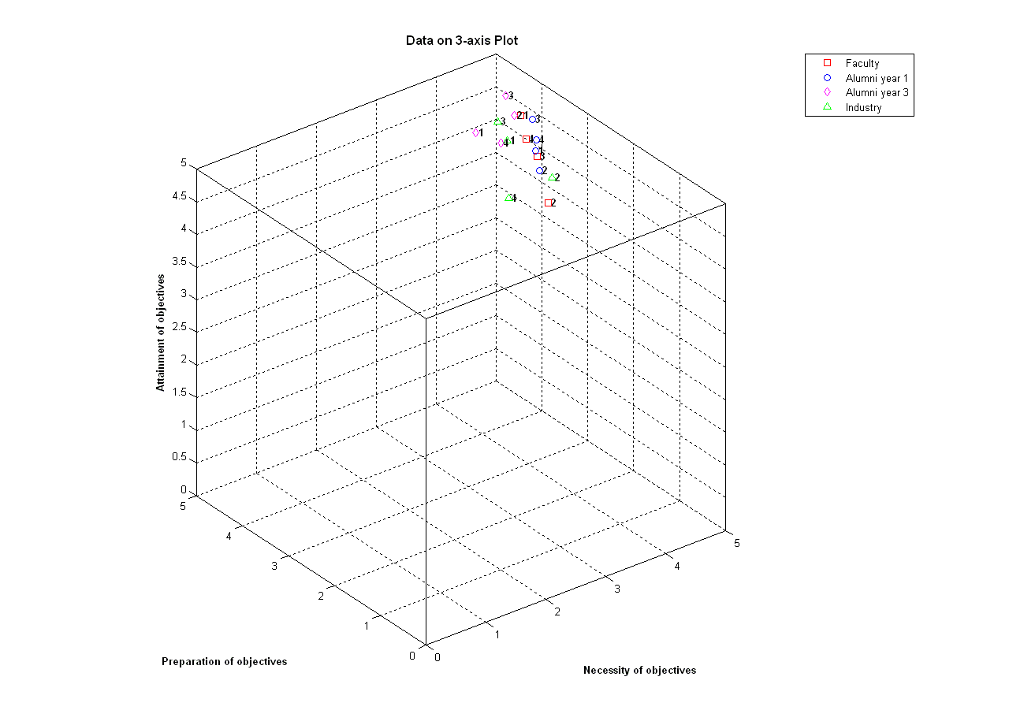
Fig. 1 Plot of the average numerical scores vs. Attainment, Necessity, and Preparation

For example, if there were a point for an objective near the origin, then there may an objective that is unnecessary, unprepared for in our program, and unattained in the careers of our graduates. Since we can visually verify that all the average numerical scores are far from the origin, along with the numerical values in Table 2, we conclude that our objectives are necessary, prepared for in our program, and attained in the careers of our graduates. We also note that the written comments in the survey forms, our interaction in the faculty and industrial advisory meetings, and other input and feedback by and large confirm the results of our analyses.
Furthermore, we note that, similar analyses have been conducted according to the identical process for the objective evaluation during Fall 2008-Spring 2009. Finally, we note that we will utilize the gap analysis further in our continuous improvement process, which will be elaborated in Section 5. We now proceed to Section 4, presenting how the assessment and evaluation are conducted for student outcomes, which are the drivers of our continuous improvement efforts in Section 5.

4. Student Outcomes Assessment and Evaluation

In this section, we explain the assessment and evaluation processes for the student outcomes as well as results of such processes in details. For the assessment of the student outcomes, we employ a combination of direct and indirect approaches consisting of instructors-driven rubrics and students and alumni-driven surveys.

4.1 Direct Assessment by the Instructors-Driven Rubrics
Let us first explain the instructors-driven rubrics approach as follows (see e.g., Table 4 below for Outcome (a)). Even though the student outcomes can be achieved by IE majors via diverse optional educational experiences at Iowa State University, which may include internships and student organization activities, the primary way of achieving such outcomes is through the courses specified in the IE curriculum course requirements.
These requirements consist of IE and non-IE courses, some of which are required while the others are from various lists of electives. We believe that all these courses contribute significantly towards the achievement of the outcomes by our students. To ensure that the achievement of all the outcomes is fostered and facilitated for all IE majors within a standard IE curriculum, however, the IE program places a heavy emphasis on the following 12 courses (consisting of fundamental manufacturing, human factors, and operations research courses) that are mandatory for IE majors. This is consistent with the guidelines provided by ABET Program Evaluator (PEV) Refresher Training Program in Module 4 [11], which specifies that the evidence of the student outcomes “should be the product of faculty reviewing and/or observing student work related to the program requirements.”
In particular, these required IE courses serve as a primary vehicle through which the student outcomes can be assessed. The mapping of the 12 required IE courses to the 13 outcomes, which specifically shows how these courses are related to the outcomes, is shown in Table 3 as follows.

Required Courses | Outcome items | a | b | c | d | e | f | g | h | i | j | k | l | m
IE 101 |  |  |  |  |  |  | x |  |  |  | x
IE 148 |  | x |  |  |  | x |  |  |  |  |  | x | x
IE 248 |  | x | x |  |  |  |  | x |  |  | x | x
IE 271 |  |  | x | x |  |  |  |  |  |  |  | x | x
IE 305 |  | x |  |  | x | x |  |  | x |  |  | x | x | x
IE 312 |  | x |  |  |  | x |  | x |  |  |  | x | x
IE 341 |  |  |  |  | x | x |  |  |  | x | x |  | x | x
IE 348 |  | x | x |  |  |  | x |  |  | x |  | x
IE 361 |  | x | x | x |  | x |  | x
IE 413 |  |  |  |  |  | x |  |  |  |  |  | x | x
IE 441 |  | x |  | x | x | x | x | x | x | x | x | x | x | x
IE 448 |  |  |  | x |  |  |  |  |  |  | x | x | x

Table 3 Mapping of the required IE Courses to the student outcomes

We note that Table 3 shows the relevance and appropriateness of each course to various outcomes (marked by x), which can be assessed as needed. This table does not necessarily show all the possible or remotely related outcomes that can be assessed for each course.
When an outcome is assessed in a required IE course, the instructor is asked to use the pre-specified rubric for the outcome. The rubric for the outcome, in turn, consists of three rows of subcriteria that collectively explain the outcome and three columns of the degree of achievement for each subcriterion. For example, the rubric for outcome item (a) is as follows. As one can observe, the maximum score of a rubric is 18 while the minimum is 3.
(a) an ability to apply knowledge of mathematics, science, and engineering

Performance Criteria
Item | Exemplary 5-6 | Acceptable 3-4 | Poor 1-2 | Score
Ability to apply general mathematical principles | Correct mathematical principles are chosen and applied without error | In general correct mathematical principles are chosen with minor errors in their application | Incorrect principles are chosen for the given engineering problem and/or there are major errors in their application
Ability to apply general scientific knowledge | Demonstrates good general knowledge of scientific principles and the ability to correctly apply them to engineering problems | Basic scientific knowledge is demonstrated with only minor errors in application to engineering problems | A general lack of scientific knowledge is demonstrated and/or the inability to apply this knowledge to engineering problems
Ability to apply general engineering knowledge | Demonstrates good general knowledge of engineering principles and their application to engineering problems | Basic engineering knowledge is demonstrated with only minor errors in application to basic engineering problems | A general lack of general engineering knowledge is demonstrated and/or the inability to apply this knowledge to basic problems
Total

Table 4 Rubric for outcome (a)

In the early part of each semester, the director of undergraduate studies, often based on the practice of past years, invites all the instructors of the required courses in the semester to assess a few relevant and appropriate outcomes shown in Table 3. In a typical course, the number of outcomes to be assessed is one or two, but an exception can be made. For example, due to the summative nature and value of the outcome assessment conducted in the capstone design course, more than two outcomes are directly measured in IE 441. On the other hand, to strike a balance and to cross-check the validity, many outcomes are directly measured across the curriculum outside the capstone design course. The goal of this assignment is that all 13 outcomes are assessed via the rubrics at least once in an academic year. Empirically, this goal has always been met or exceeded.
In implementing the direct measurement of outcomes via the rubrics, we closely follow the guidelines provided by ABET Program Evaluator (PEV) Refresher Training Program in Module 4 [11]. For example, “appropriate sampling methods may be used as part of an assessment process.” In view of such guidelines, our approach is substantially different from an approach to assess each student with respect to each outcome in each course in every semester (i.e., a significantly inordinate faculty load) as follows:
Once the assignments are made, the instructors complete and report the direct measurement of the outcomes before the beginning of the next semester. Some instructors, for example, utilize some specific parts in a course project report, an exam, a homework set, etc. When there are more than 20 data points for the direct measurement, the instructors have an option of sampling 20 data points randomly for the direct measurement. This policy was instituted to avoid any inordinate faculty program assessment load for instructors with an enrollment level of perhaps 70 to 80 IE majors.
Thus far, we have explained the direct assessment by the instructors-driven rubrics. Let us now proceed to explain the indirect assessment by the students and alumni-driven surveys as follows.

4.2 Indirect Assessment by the Students and Alumni-Driven Surveys
In addition to the direct measurement via the rubrics, we also gather the relevant and appropriate indirect measurements via the surveys as follows. At the end of both Fall and Spring semesters, graduating seniors are asked about each student outcome in the form of
Indicate your personal satisfaction with how your undergraduate education in industrial engineering helped you to: (1 = not satisfied at all; 5 = very satisfied)
Also, around the midpoint of each academic year, Year 1 alumni are asked about each student outcome in the form of
How well did your education in IE at ISU help your ability to: (1 = not at all; 5 = extremely well)
We note that perhaps the seniors are the most appropriate students for the survey as their opinions by the time of their graduation is summative. We also note that the Year 1 alumni (who graduated last calendar year) should provide a different, yet valid perspective on their very recent educational experience.
We now explain the assessment and evaluation processes for the student outcomes as well as our expectation and results in the following three subsections.

4.3 Assessment and Evaluation Processes for Student Outcomes
For the direct and indirect measurement data of the previous semester, at the beginning of each semester, the director of the undergraduate studies, with the help of the chair, curriculum committee, academic advisor, staff, a graduate assistant, and the relevant faculty, collect, compile, and organize the data. We note that, in addition to the aforementioned three principal instruments of outcome measurement, we may utilize additional information (qualitative, anecdotal, and/or quantitative) from Faculty and Industry Advisory Council meetings, student focus group meetings, OPAL (Online Performance and Learning; observation frequency based assessment of coop/internship students; coop/internship is encouraged, but not required), inputs from internal and external administrative units, etc.
The organized data are primarily in the form of numerical values. Hence, they can be easily evaluated quantitatively and objectively by the director of the undergraduate studies. Depending on the major findings of this evaluation, in conjunction with any other relevant input, we note that further evaluation processes may be necessary, and they are elaborated in the subsection of 4.6 Further Information on Outcome Evaluation Processes.
The current assessment processes for the instructors-driven rubrics and the graduating students-driven surveys are for both Fall and Spring semesters of each year. The Year 1 alumni-driven surveys are for an approximately midpoint of each academic year. To be more precise, since the program educational objectives alumni survey of Spring 2011, the alumni survey has moved to early Spring (cf. before Spring 2011, the alumni survey was conducted late Fall).

4.4 The Expected Level of Attainment for Each of the Student Outcomes
We do not have a single number from a single source (e.g., instructors, graduating seniors, or Year 1 alumni) that will assure the attainment of each student outcome. However, by the design of the survey questions (a numerical score of 1 to 5), an average score of an outcome that is greater than 3 in a survey can be viewed as an evidence illustrating that the level of the student outcome achievement is satisfactory. Furthermore, by the design of the rubrics (a numerical score of 3 to 18), an average score of an outcome that is greater than 9 (when averaged over all corresponding courses and instructors during an academic year) can be viewed as an evidence illustrating that the level of achievement is satisfactory.
In general, if and when all three metric values that are obtained independent of each other support that the level of the student outcome achievement is satisfactory (triangulation), then a convincing case is made that the level of achievement is indeed satisfactory. In our case, we expect that, for each student outcome in an academic year (basically Fall and Spring semesters), the average numerical scores from the graduating senior and Year 1 alumni surveys are all higher than 3 AND the average rubric score(s) from the primary rubric-based data set is (are all) higher than 9 if a satisfactory level of attainment is achieved. We note that the numerical score ranges from 1 (worst) to 5 (best) in a survey while the rubric score ranges from 3 (worst) to 18 (best).
Concurrently, for the primary rubric-based data set, we institute the percentage of students with the rubric score of 9 or higher as an additional performance indicator. We expect that, for each student outcome in an academic year (basically Fall and Spring semesters), this indicator is higher than 70% if a satisfactory level of attainment is achieved. Combining this performance indicator with the aforementioned scores, for each student outcome, we expect that a satisfactory level of attainment is achieved if the average survey scores are all higher than 3, the average rubric score(s) is (are all) higher than 9, AND the performance indicator percentage is higher than 70%.
By cross-checking the results from the three independent sources of the graduating students, Year 1 alumni, and rubrics, we believe that our conclusion is robust and entirely plausible as the possibility of all results from these sources coincidently being wrong is remote. The actual (cf. expected) levels of attainment will be elaborated in the next subsection.

4.5 Results of Student Outcomes Assessment and Evaluation
The primary rubric-based data sets for the last five semesters are as shown in Table 5 where, within a class in a semester, the first number is the average rubric score (18 being the best and 3 being the worst) and the number in the parenthesis is the aforementioned performance indicator percentage.

ABET Criterion 3 Outcomes | Fall 2009 | Spring 2010 | Fall 2010 | Spring 2011 | Fall 2011
a. an ability to apply knowledge of mathematics, science, and engineering | IE305A  16.07 (100%) | IE305B  11.00  (50%) |  | IE305A  14.89  (94.4%)
b. an ability to design and conduct experiments, as well as to analyze and interpret data |  | IE271  16.65  (100%)  IE361  16.81  (100%) | IE361  15.10 (100%) | IE271  16.20  (100%)
c. an ability to design a system, component, or process to meet desired needs within realistic constraints such as economic, environmental, social, political, ethical, health and safety, manufacturability, and sustainability | IE441  14.10 (100%) | IE441  11.90 (74.19%) | IE441  13.61 (100%) | IE441  12.39  (100%) | IE441  12.31  (100%)
d. an ability to function on multidisciplinary teams | IE341  14.93 (100%) | IE441  15.16 (87.10%) | IE341  14.75 (100%) | IE441  15.70  (100%) | IE341  12.69  (87.5%)
e. an ability to identify, formulate, and solve engineering problems | IE148  14.68 (94.74%)  IE305B  16.18 (100%)  IE312  12.15  (90%) | IE148  14.95  (100%) | IE148  12.80 (100%)  IE305B  18.90 (100%) | IE148  11.20  (90%) | IE148  12.50  (90%)  IE305B  16.89  (100%)
f. an understanding of professional and ethical responsibility | IE441  16.90 (100%) | IE348  13.70  (100%) | IE441  16.06 (100%) | IE348  15.84  (100%) | IE441  15.56  (100%)
g. an ability to communicate effectively | IE441  15.24 (100%) | IE441  13.55 (87.10%) | IE441  14.97 (100%) | IE441  14.22  (100%) | IE441  14.38  (100%)
h. the broad education necessary to understand the impact of engineering solutions in a global, economic, environmental, and societal context | IE441  16.57 (100%) | IE441  12.68 (90.32%) | IE441  13.00 (100%) | IE441  14.13  (100%) | IE441  15.13  (100%)
i. a recognition of the need for, and an ability to engage in life-long learning | IE441  15.14 (100%) | IE348  12.70  (100%) | IE441  15.13 (100%) | IE348  14.76  (100%) | IE441  16.31  (100%)
j. a knowledge of contemporary issues |  | IE448  10.90  (80%) | IE341  17.19 (100%) | IE448  11.95  (95%) | IE341  12.25  (87.5%)
k. an ability to use the techniques, skills, and modern engineering tools necessary for engineering practice | IE148  12.84 (78.95%)  IE248  13.90 (100%)  IE413  12.35  (80%) | IE148  15.50  (95%) | IE148  9.90  (50%)  IE248  13.75 (100%)  IE413  11.10  (80%) | IE148  9.70  (50%) | IE148  12.30  (80%)  IE413  11.70  (100%)
l. an ability to design, develop, implement, and improve integrated systems that include people, materials, information, equipment and energy | IE413  11.30  (85%) | IE441  14.13 (74.19%)  IE448  12.40  (85%) | IE413  10.75  (80%) | IE441  15.87  (100%)  IE448  9.55  (70%) | IE413  10.80  (90%)
m. an ability to provide leadership in multi-functional teams. | IE341  13.67 (100%) | IE305A  15.30  (100%) | IE305A  16.10 (100%)  IE341  16.07 (100%) |  | IE305A  14.00  (100%)  IE341  13.19  (93.75%)

Table 5 Rubric-based data sets

As one can easily observe, the actual attainment levels typically far exceed the expected attainment levels. We note that the number of students within a class (or a section in a class) in a semester varies as the numbers of IE majors assessed/enrolled in it vary. Even in cases where the actual attainment does not appear to far exceed the expectation at a first glance, a little bit of further investigation confirms that it actually is the case. For example, for Outcome (a), the academic year performance indicator percentage for Fall 2009-Spring 2010 is 94.12% while for Outcome (k), the performance indicator across the courses in Fall 2010 is 80.43%. We also note that the older data sets of the prior years exhibit the similar characteristics.
As for the graduating students in the same period, the survey results are as in Table 6 where, within a semester, the average score for each outcome is shown (5 being the best and 1 being the worst).

ABET Criterion 3 Outcomes | Fall 2009 | Spring 2010 | Fall 2010 | Spring 2011 | Fall 2011
# of Respondents | 21 | 30 | 31 | 23 | 16
a. an ability to apply knowledge of mathematics, science, and engineering | 4.43 | 4.38 | 4.55 | 4.57 | 4.25
b. an ability to design and conduct experiments, as well as to analyze and interpret data | 4.33 | 4.17 | 4.39 | 4.48 | 4.31
c. an ability to design a system, component, or process to meet desired needs within realistic constraints such as economic, environmental, social, political, ethical, health and safety, manufacturability, and sustainability | 4.38 | 4.28 | 4.42 | 4.52 | 4.31
d. an ability to function on multidisciplinary teams | 4.57 | 4.37 | 4.55 | 4.65 | 4.56
e. an ability to identify, formulate, and solve engineering problems | 4.57 | 4.34 | 4.48 | 4.57 | 4.25
f. an understanding of professional and ethical responsibility | 4.67 | 4.28 | 4.48 | 4.78 | 4.63
g. an ability to communicate effectively | 4.57 | 4.18 | 4.65 | 4.48 | 4.56
h. the broad education necessary to understand the impact of engineering solutions in a global, economic, environmental, and societal context | 4.33 | 4.03 | 4.16 | 4.61 | 4.19
i. a recognition of the need for, and an ability to engage in life-long learning | 4.71 | 4.37 | 4.74 | 4.57 | 4.69
j. a knowledge of contemporary issues | 4.29 | 4.10 | 4.13 | 4.39 | 3.88
k. an ability to use the techniques, skills, and modern engineering tools necessary for engineering practice | 4.38 | 4.17 | 4.39 | 4.57 | 4.06
l. an ability to design, develop, implement, and improve integrated systems that include people, materials, information, equipment and energy | 4.38 | 4.14 | 4.35 | 4.52 | 4.13
m. an ability to provide leadership in multi-functional teams. | 4.67 | 4.45 | 4.71 | 4.70 | 4.56

Table 6 Graduating Students Survey results

As one can easily observe, the actual attainment levels far exceed the expected attainment levels for each outcome. We also note that the older data sets of the prior years exhibit the similar characteristics.
As for the Year 1 alumni in the same period, the survey results are as in Table 7 where, within a year, the average score for each outcome is shown (5 being the best and 1 being the worst).

ABET Criterion 3 Outcomes | Year 09-10 | Year 10-11 | Year 11-12
# of Respondents | 14 | 13 | 8
a. an ability to apply knowledge of mathematics, science, and engineering | 4.36 | 4.54 | 4.75
b. an ability to design and conduct experiments, as well as to analyze and interpret data | 4.15 | 4.31 | 4.00
c. an ability to design a system, component, or process to meet desired needs within realistic constraints such as economic, environmental, social, political, ethical, health and safety, manufacturability, and sustainability | 4.23 | 4.31 | 4.38
d. an ability to function on multidisciplinary teams | 4.50 | 4.38 | 4.50
e. an ability to identify, formulate, and solve engineering problems | 4.21 | 4.46 | 4.57
f. an understanding of professional and ethical responsibility | 3.86 | 4.38 | 4.00
g. an ability to communicate effectively | 4.29 | 4.62 | 4.13
h. the broad education necessary to understand the impact of engineering solutions in a global, economic, environmental, and societal context | 3.64 | 4.23 | 4.29
i. a recognition of the need for, and an ability to engage in life-long learning | 4.07 | 4.58 | 4.00
j. a knowledge of contemporary issues | 3.71 | 4.08 | 3.63
k. an ability to use the techniques, skills, and modern engineering tools necessary for engineering practice | 3.79 | 4.33 | 4.57
l. an ability to design, develop, implement, and improve integrated systems that include people, materials, information, equipment and energy | 3.71 | 4.38 | 4.57
m. an ability to provide leadership in multi-functional teams. | 4.14 | 4.54 | 4.50

Table 7 Year 1 Alumni Survey Results

As one can easily observe, the actual attainment levels far exceed the expected attainment levels for each outcome. We also note that the older data sets of the prior years exhibit the similar characteristics.
We also note that the written comments in the survey and rubric forms, our interaction in the faculty and industrial advisory meetings, and other input and feedback by and large confirm the results of our analyses. Furthermore, we note that, all the data in the prior years since the last general review exhibits the similar characteristics.
All in all, one can observe that all three average values as well as the performance indicator percentage far exceed the expected levels of the satisfactory attainments. Hence, we conclude that the attainment of these outcomes by the IE majors by the time of their graduation has been convincingly demonstrated (average-wise as well as percentage-wise). We do note that the summary of the outcomes in and of itself does not seem to radically change in recent years as the numerical data indicate a high level of attainment that is consistent and stable. We also note that we will utilize these data further in our continuous improvement process, which will be elaborated in Section 5.
Finally, as mentioned earlier (Subsection 4.3), for some outlying cases, it may be necessary to employ a more elaborate evaluation process. This is described in the following subsection.

4.6 Further Information on Outcome Evaluation Processes
As we mentioned in the subsection of 4.3 (Assessment and Evaluation Processes for Student Outcomes), at the beginning of each semester, a straightforward and quantitative review of the numerical values of the available data by the director of undergraduate studies is often sufficient to conclude that the student outcomes are achieved at a satisfactory level. This is consistent with the Evaluator (PEV) Refresher Training Program in Module 4 [11], which states that a program does not have to assess every outcome every year to know how well it is doing toward attaining student outcomes (outcomes not assessed every year necessarily imply that they are not evaluated every year).
In any case of unusual deviations from the high level of attainment that has been consistent and stable in recent years, or for the outcome items of special interests such as being a part of continuous improvement efforts for the program educational objectives (see the subsection of 5.1 Usage of Evaluation Results for Continuous Improvement of the Program), the director of undergraduate studies may call for a more elaborate evaluation process as follows:
We note that all steps are on an as-necessary basis.
1. Around early Fall semester, in the meetings of the curriculum committee/the faculty, based on the available data, formal evaluation and improvement decisions on outcomes are made.
2. During Fall semester, improvement efforts are made.
3. Around early Spring semester, in the meetings of the curriculum committee/the faculty, based on the available data, formal evaluation and improvement decisions on outcomes are made.
4. During Spring semester, improvement efforts are made.
5. During the Industrial Advisory Council meeting, the council’s input on outcomes are solicited.
Finally, we note that what has been described in this subsection and the previous subsection of 4.3 is to effect outcome improvement efforts based on the evaluation of PEO’s. We now formally present our continuous improvement efforts as follows.

5. Continuous Improvement

The continuous improvement process for the objectives and outcomes is depicted in Fig. 2 as follows.

Industrial Engineering Program Objectives
Determined/Changed
Industrial Engineering Student Outcomes Determined/Changed
Outcome Improvement and Refinement
Internal and External Outcome Assessment
Teaching and Learning
Objective Improvement and Refinement
Internal and External Objective Evaluation
Direction of Primary Influence
Other Stakeholders
(ABET, ISU Administrators, etc.)

Fig. 2 Continuous improvement process for objectives and outcomes

The left-hand side cycle is for every 3 years while the right-hand cycle is for every semester. By following the direction of the primary influence, one can observe how the outcomes support the later attainment of the objectives and how the objectives can effect changes in outcomes if and when necessary.
In what follows, we first describe how the program educational objective evaluations have led to the continuous improvement efforts in the student outcomes.

5.1 Usage of Evaluation Results for Continuous Improvement of the Program
As one can recall from Section 3, the program educational objective evaluation led to the conclusion that the current objectives are necessary, prepared for in our program, and attained in the careers of our graduates. For a deeper analysis, we employed the following three figures of Preparation vs. Attainment, Necessity vs. Attainment, and Necessity vs. Preparation with a value of (2.5, 2.5) as the origin. We also note that, for the figure of Necessity vs. Preparation, we were able to include the students as a primary constituency.
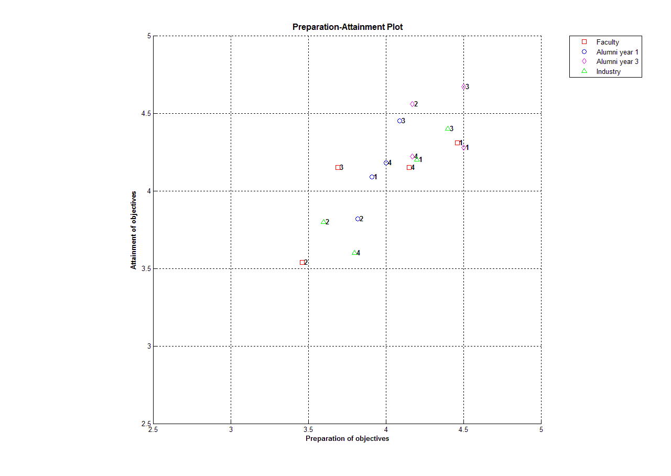
Fig. 3 Preparation vs. Attainment

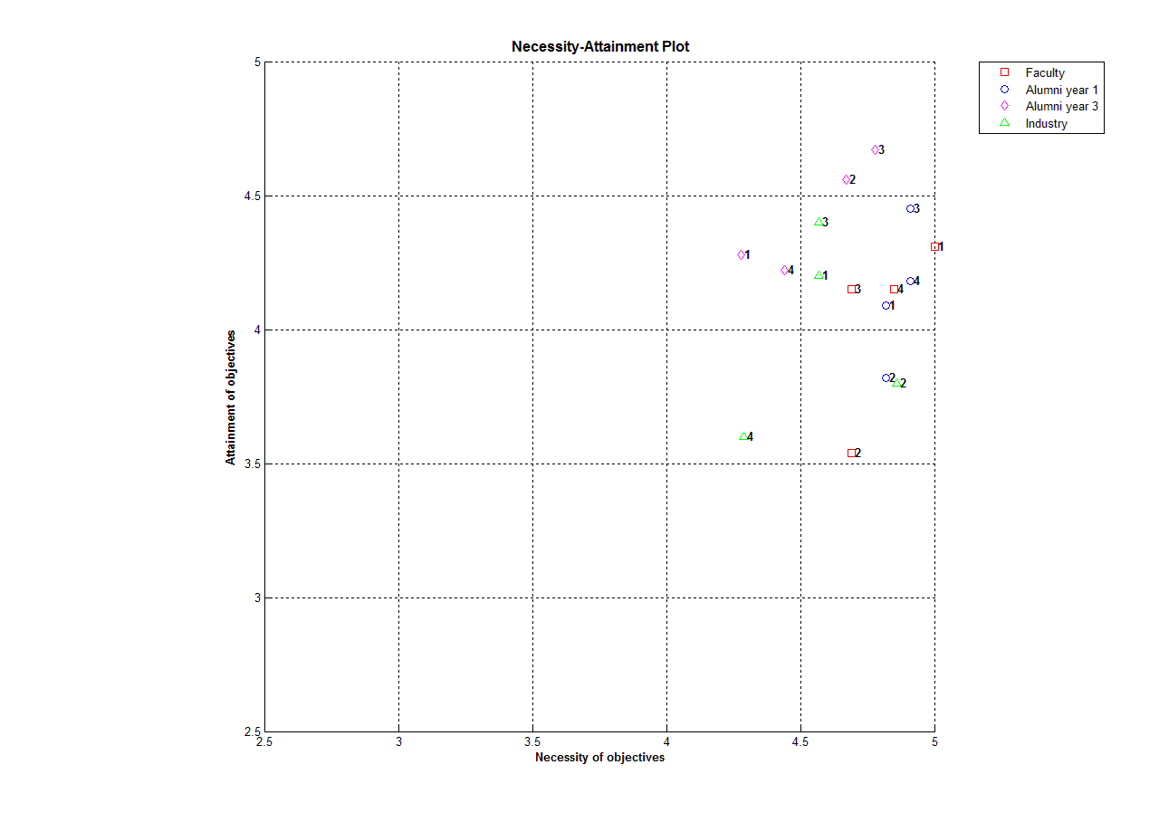
Fig. 4 Necessity vs. Attainment

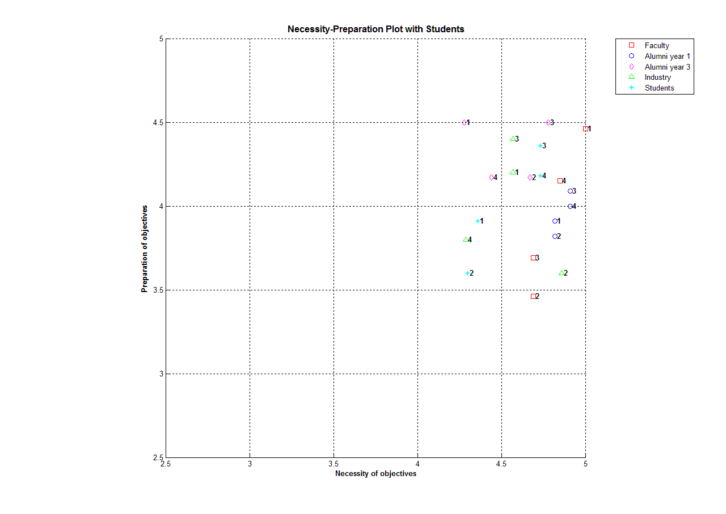
Fig. 5 Necessity vs. Preparation

By visually inspecting the gaps between the three key aspects of the program educational objectives of Attainment, Necessity, and Preparation, the curriculum committee concluded that Objective 2 relatively seemed to be in need of improvement. The department faculty agreed and recommended additional efforts to foster the achievement of Objective 2. This would be facilitated by efforts to improve Outcome (g), an ability to communicate effectively. For this improvement, IE 248, a required manufacturing course, would be adding a written communication module and IE 441, a required capstone design course, would utilize its peer feedback process as a communication module in Fall 2011.
As of now, we do have the following baseline on Outcome (g):
-Fall 2011:
IE 441: 14.38 (100%)
Graduating students: 4.56
- Year 11-12:
Year 1 alumni: 4.13
As we track more Outcome (g) data over the next three years or so (the program objectives evaluation cycle length is 3 years), we will be able to learn more about the effectiveness of these improvement initiatives, and, if necessary, make further efforts.
Through a similar analysis during the Fall 2008-Spring 2009 program educational objective evaluation, even though the objectives then were achieved at a satisfactory level, Objective 6 relatively seemed to be in need of improvement. We note that Objective 6 was “new skills and training for lifelong learning and professional development.” This objective has been re-worded to “new skills and knowledge that advance professional practice and enable career advancement” in our current Objective 4 to better reflect the recent ABET emphasis on “broader” PEO’s.

In response, at that time, the department faculty recommended additional efforts to foster the achievement of Objective 6. This was facilitated by efforts to improve Outcome (i), a recognition of the need for, and an ability to engage in life-long learning. For this improvement, IE 348, a required manufacturing course, added how to utilize professional magazines in the class and IE 441, a required capstone design course, added how to learn from peer feedback in the class.
The outcome data that are most relevant to this previous initiative are:
-Fall 2009: IE 441: 15.14 (100%)
Graduating students: 4.71
Year 1 alumni (prior to the initiative): 4.07
-Spring 2010: IE 348: 12.70 (100%)
Graduating students: 4.37
-Fall 2010: IE 441: 15.13 (100%)
Graduating students: 4.74
Year 1 alumni (after the initiative): 4.58
We observe that the rubrics and graduating senior survey results seem strong and robust, and the improvement in the Year 1 alumni survey seems encouraging.

6. Conclusion

In this paper, we have shown how the assessment and evaluation of the PEO’s and outcomes can be systematically conducted. We have also shown how the results of the PEO’s evaluation lead to the improvement efforts through the student outcomes.
In so doing, we have documented step by step how the ABET expectations can be met so that various accreditation stakeholder might be able to specifically prepare for the critical stages and move forward to close the loop for a continuous improvement cycle.
We also note that our systematic way of continuous improvement does not necessarily prevent any individual instructor from initiating one’s own improvement endeavors (see e.g., [12] for improvement in leadership, teamwork, and contemporary issues). Rather, we view the systematic way of improvement as a required expectation while the individually initiated endeavors as an elective expectation. Ultimately, they both should be able to significantly contribute to better learning experiences by the students in an accredited engineering program.
Based on our experience, there exist several critical challenges on the assessment, evaluation, and continuous improvement. For example, how does one strike a balance between the ideal conceptual framework and current practice with substantial resource constraints? Such efforts require personnel time as well as money, and in a period of decreasing budget, it is currently unclear which activities should be adjusted accordingly.
From a methodology perspective, as [13] correctly points out, tracing and attributing any actual improvement to a particular set of continuous improvement efforts have never been exact in practice. Therefore, more accurate measuring of the degree of such contributions would be highly desirable.

References

- ABET Annual Report 2008, http://www.abet.org/uploadedFiles/Publications/Annual_Report/abet-2008-annual-report.pdf , Accessed May 2012.
- ABET Criteria for Accrediting Engineering Programs, 2012 – 2013, http://abet.org/engineering-criteria-2012-2013/ , Accessed May 2012.
- K. Edwards, E. Fernandez, T. Milionis, and D. Williamson, EAST: developing an electronic assessment and storage tool, Assessment and Evaluation in Higher Education, Vol. 27, pp. 95-104, 2002.
- R. Miller, and B. Olds, An assessment matrix for evaluating engineering programs, Journal of Engineering Education, Vol. 87, pp. 172-179, 1998.
- N. Soundarajan, Program assessment and program improvement: closing the loop, Assessment and Evaluation in Higher Education, Vol. 29, pp. 597-610, 2004.
- ABET Self-Study Questionnaire (Engineering), http://abet.org/download-self-study-templates/ , Accessed May 2012.
- D. Hokanson, L. Phillips, and J. Mihelcic, Educating engineers in the sustainable futures model with a global perspective: Education, research and diversity initiatives, International Journal of Engineering Education, Vol. 23, pp. 254-265, 2007.
- P. Ball, H. Grierson, K. J. Min, J. Jackman, and P. Patterson, Working on an assignment with people you’ll never meet! Case study on learning operations management in international teams, International Journal of Engineering Education, Vol. 23, pp. 368-377, 2007.
- S. Ludi, and J. Collofello, An analysis of the gap between the knowledge and skills learned in academic software engineering course projects and those required in real projects, Proceedings of Frontiers in Education Conference, Reno, NV, October 2001.
- M. Oliver-Hoyo, and D. Allen, The use of triangulation methods in qualitative educational research, Journal of College Science Teaching, Vol. 35, pp. 42-47, 2006.
- ABET Program Evaluator (PEV) Refresher Training Program in Module 4 at http://www.abet.org/pev-refresher-training-module4/ , Accessed May 2012.
- K. J. Min, and W. Shi, Learning improvement in leadership, teamwork, and contemporary issues through a global supply chain project, Proceedings of the ASEE Annual Conference, Vancouver, Canada, June 2011.
- J. Lohmann, Voice of experience, ASEE Prism, Vol. 7, Page 124, 1998.

List of figures and tables

Fig. 1 Plot of the average numerical scores vs. Attainment, Necessity, and Preparation
Fig. 2 Continuous improvement process for objectives and outcomes
Fig. 3 Preparation vs. Attainment
Fig. 4 Necessity vs. Attainment
Fig. 5 Necessity vs. Preparation

Table 1 Mapping of objectives to outcomes
Table 2 Average scores of each objective for each constituency
Table 3 Mapping of the required IE Courses to the student outcomes
Table 4 Rubric for outcome (a)
Table 5 Rubric-based data sets
Table 6 Graduating Students Survey results
Table 7 Year 1 Alumni Survey Results

Biography
K. Jo Min is an Associate Professor and Director of Undergraduate Studies in the Department of Industrial and Manufacturing Systems Engineering at Iowa State University. He teaches courses in sustainable production systems and market-based allocation mechanisms. His education research interests include continuous improvement for objectives and outcomes, teaching and learning of global enterprise perspectives, and international student team management and effectiveness. His research publications have appeared in International Journal of Engineering Education, The Engineering Economist, IEEE Transactions on Engineering Management, and others. He is a member of IIE and INFORMS.
John Jackman is an Associate Professor in the Department of Industrial and Manufacturing Systems Engineering at Iowa State University. His research interests include enterprise computing, information engineering, and manufacturing systems engineering. He has had extensive experience in the aerospace, defense, pharmaceutical, and software development industries. His research has appeared in technical papers published in journals by the Institute of Industrial Engineers, Institute of Electrical and Electronics Engineering, and the American Society of Mechanical Engineers, as well as others.
Douglas D. Gemmill is an Associate Professor of Industrial Engineering and Chair of the Systems Engineering graduate program at Iowa State University. He teaches undergraduate courses in simulation and stochastic processes and graduate courses in systems engineering. His professional interests include systems engineering, applied operations research and the modeling, design, and performance analysis of manufacturing systems. He is a member INCOSE, ASEE, and a senior member of IIE.

